**Hybrid Approach for Credit Risk Assessment: Combining Deep Learning and Machine Learning Techniques for Credit Card Assessments**

SIBEL KUSAK

A Thesis Submitted in Partial Fulfilment

of the requirements for the

Degree of

Master of Science in Data Analytics



September 2023

Supervisor: David McQuaid

# CCT College Dublin

|  |  |
| --- | --- |
| **Module Title:** | Capstone Project |
| **Assessment Title:** | Hybrid Approach for Credit Risk Assessment: Combining Deep Learning and Machine Learning Techniques for Credit Card Assessments |
| **Supervisor Name:** | David McQuaid |
| **Student Full Name:** | Sibel Kusak |
| **Student Number:** | 2022077 |
| **Assessment Due Date:** | 24th of September 2023 |
| **Date of Submission:** | 23rd of September 2023 |

## Declaration

By submitting this assessment, I confirm that I have read the CCT policy on Academic Misconduct and understand the implications of submitting work that is not my own or does not appropriately reference material taken from a third party or other source. I declare it to be my own work and that all material from third parties has been appropriately referenced. I further confirm that this work has not previously been submitted for assessment by myself or someone else in CCT College Dublin or any other higher education institution.

# Abstract

The project aims to improve credit card risk assessment through a hybrid technique that blends Random Forest and Deep Learning algorithms. In today's unpredictable financial world, accurate risk assessment is critical. Combining the benefits of both algorithms, this hybrid model attempts to produce a more accurate categorisation of credit card default risk. To exploit complex patterns in data, the Deep Learning framework employs multi-layered neural networks and the Random Forest method. Random Forest provides ensemble-based robustness. The Voting Ensemble approach combines the predictions of the two algorithms to get a comprehensive and balanced result. Data preprocessing, which includes data cleaning, addressing missing values, and categorical variable conversion, is the first step in the investigation. The Standard Scaler is then used to normalise the data. In order to handle complicated features and probable non-linear interactions, the Random Forest method is then used. The Deep Learning component uses the Sequential design to exploit its ability to unearth complex data representations. The hybrid model achieves an accuracy of roughly 83.03%, showing encouraging results. The ROC curve highlights the model's potent discrimination skills, which have an AUC-ROC value of 0.92. Utilising the advantages of both strategies, the Voting Ensemble technique, which combines both algorithms, provides a comprehensive solution for credit card risk assessment. This study advances credit risk assessment approaches, promoting better financial judgment in a credit environment that is continually changing.

Table of Contents

Abstract 3

List of images 6

List of Tables 6

Chapter 1 Introduction 7

1.1 Background 7

1.2 Motivation 8

1.3 Problem Statement 9

1.4 Research Objectives 10

1.5 Research Questions 11

1.6 Dissertation Organization 11

Chapter 2 Literature Review 13

2.1 Introduction 13

2.2 Credit Risk Assessment Techniques 13

2.3 Deep Learning Techniques for Credit Risk Assessment 17

2.4 Summary 20

Chapter 3 Sampling Strategy 21

3.1 Introduction 21

3.2 Population of Interest 21

3.3 Stratified Sampling: 21

3.4 Ethical Consideration 23

Chapter 4 Methodology 25

4.1 Data Description 25

4.2 Data analysis and preprocessing 26

4.3 SMOTE 27

4.4 Ensemble Learning VotingClassifier 29

**4.1.1Decsion tree** 29

**4.1.2 Gradient Boosting** 30

**4.1.3 Voting Classifier** 31

4.5 LSTM Model 32

4.6 Hybrid Model 33

**4.6.1 Convolutional Neural Networks.** 33

**4.6.2 KNN model** 34

**4.6.3 Random Forest Model** 35

4.7 Model Evaluation 36

4.8 ROC curve 38

4.9 Hardware Tools 39

4.10 Software Tools 39

4.11 Conclusion 39

Chapter 5 Results 41

5.1 Dataset Read and Load 41

5.2 Dataset Analysis 42

5.3 Dataset Visualisation 42

5.4 Handling Missing Values in Dataset 46

5.5 Analyzing Class Imbalance in the Target Variable 49

**5.5.1 Balancing Class Distribution Using SMOTE** 50

5.6 Results of Machine and Deep Learning Models 51

**5.6.1 Results of Ensemble Learning VotingClassifier** 51

**5.6.2 Results of LSTM Model** 52

**5.6.3 Hybrid Model Results using k-Nearest Neighbors, Decision Tree, and Deep Learning** 53

**5.6.4 A hybrid Model Using Random Forest and Deep Learning, the Voting Ensemble Technique.** 55

5.7 Comparison of Different Approaches for Credit Card Risk Assessment: 57

Chapter 6 Conclusion Dissuasion 58

6.1 Conclusion 58

6.2 Discussion 58

6.3 Future Recommendation 59

References 62

# List of Images

Figure 1: *SMOTE and Repeated Oversampling Decision Tree Sizes for the Mammography Dataset330*(Chawla et al., 2002) 26

Figure 2: *Comparison of SMOTE and % Minority Correct for Replicated Oversampling in the Mammography Dataset*(Chawla et al., 2002) 27

Figure 3: Unit Structure of LSTM(Zhang, 2022) 31

Figure 4: Dataset Load and Read 39

Figure 5: Statistical Analysis of Dataset 40

Figure 6: The proportion of Defaulters Among Those Applying for Loans. 40

Figure 7: A histogram depicts the distribution of credit limits (mvar2) among credit card applicants. The distribution is biased to the right, with most applicants having lower credit limits. 41

Figure 8: The relationship between credit limitations (mvar2) and default indicator is depicted in a box plot. The graph shows that defaulters have slightly lower median credit limits than non-defaulters. 42

Figure 9: A scatter plot displaying the association between credit limits (mvar2) and credit card applicants' ages (mvar14). As a default, the plot is color-coded. There is no discernible linear trend, although there are disparities in credit limit distribution based on age. 43

Figure 10: The correlation matrix of the dataset's numerical attributes is displayed as a heatmap. Annotations in different colours emphasise the strength and direction of relationships between particular attributes. This visualisation facilitates in the identification of potential correlations between variables, which may then be used to inform subsequent analysis and model creation. 43

Figure 11: Heatmap Showing How Missing Values Are Distributed Among Dataset Columns. 44

Figure 12: Visualizing the number and proportion of missing values in each column using a bar graph. 45

Figure 13: Analyzing the Class Imbalance 46

Figure 14: No Missing Values Remain 48

Figure 15: Confusion Matrix of Voting Classifier 49

Figure 16: Confusion Matrix of LSTM Model 50

Figure 17: Confusion Matrix of Hybrid Model 1 51

Figure 18: Roc Curve for Hybrid Model 52

Figure 19: Roc Curve of Hybrid Model 2 53

Figure 20: Confusion Matrix of Hybrid Model 2 53

# List of Tables

Table 1:Confusion Matrix 33

Table 2: Comparison Table 52

# Chapter 1 Introduction

# Background

Credit risk assessment is critical in today's financial world for both financial institutions and individuals. Credit risk evaluation has become an essential aspect of lending as credit transactions have increased. Traditional credit risk assessment approaches have relied on well-established statistical and machine learning methodologies. Machine learning has significantly advanced in the last several decades, impacting business and academics. This revolutionary wave has invaded practically every aspect of human existence, including pattern recognition, picture categorisation, commercial operations, agriculture, transportation, and financial systems. This study focuses mainly on applying machine learning in finance, explicitly evaluating credit risk.

Trust and credit are critical cornerstones in modern financial arrangements. The evaluation of credit risk - a fundamental indicator tasked with evaluating and forecasting the potential of debtor default - is at the heart of these systems. The precise assessment of credit risk is of unsurpassed importance to the entire system's stability. Miscalculations in credit risk estimates can have far-reaching repercussions, potentially leading to systemic failures like the 2008 subprime crisis. As a result, lenders devote significant efforts to predicting the creditworthiness of individuals and businesses. This proactive approach enables them to develop financing methods that limit possible hazards. Credit risk assessment procedures have traditionally relied on statistical techniques such as Linear Discriminant Analysis (Moo-Young, 2019) and Logistic Regression (Cox, 1958).

The advancement in computational power and the availability of large credit-related datasets has ushered in a new era of AI-powered credit risk calculation algorithms. This technical advancement has combined classical machine learning with deep learning approaches. These developments are significantly transformational since they enable more precise and efficient credit risk evaluations than before.

Exemplars in the landscape of traditional machine learning approaches include k-Nearest Neighbor (Cover & Hart, 1967; Cox, 1958), Forest (Cortes & Vapnik, 1995), and Support Vector Machines (Goodfellow et al., n.d.). Compared to traditional statistical procedures, these methodologies are more effective and flexible. Notably, they can accept complicated patterns within credit data, allowing for more precise risk assessments.

However, converging machine learning and deep learning approaches (Goodfellow et al., n.d.) have sparked tremendous interest. These approaches have demonstrated exceptional performance advances, particularly in the realm of large credit risk datasets. Deep learning algorithms excel at both predicted accuracy and computational efficiency. Their inherent ability to learn and uncover nuanced patterns from large-scale data sources enables them to surpass traditional approaches.

As a result, combining machine learning paradigms, combining the resilience of classical methodologies, and the depth of knowledge attained through deep learning is a powerful approach to revolutionising credit risk calculation. This confluence promises to fully realise the potential of AI-driven approaches in transforming the financial sector.

# Motivation

The inexorable march of technological advancement has catalysed substantial changes in a wide range of sectors and aspects of human life. Finance is one such transformative subject, where the combination of Artificial Intelligence (AI) and machine learning has been revolutionary. Credit risk estimation is a vital subject of finance. The proper evaluation of credit risk is critical for the stability of financial systems and sensible lending practices. Following the subprime mortgage crisis 2008 and the ensuing financial upheaval, the need to improve credit risk calculation methodology has become even more pressing. Credit risk assessment has traditionally depended significantly on statistical approaches such as Linear Discriminant Analysis and Logistic Regression. While these strategies provided useful insights, they frequently needed help to deal with the intricacies inherent in large and complicated credit datasets. The growth of processing power and the availability of vast credit data heralded a new age, ushering in AI-driven credit risk estimate approaches. Combining classic machine learning and deep learning methods has facilitated this transformation. The use of machine learning in credit risk evaluation has several advantages. Techniques like k-Nearest Neighbor, Random Forest, and Support Vector Machines have outperformed their statistical equivalents regarding efficacy and flexibility. These approaches can detect detailed patterns in credit data, improving the precision of risk evaluations. Machine learning methods give a more comprehensive view of creditworthiness by combining several data sources and allowing nonlinear interactions.

Deep learning, on the other hand, is pushing the frontiers of credit risk prediction. Deep learning algorithms, which fall under the umbrella of neural networks, can automatically learn and extract subtle patterns from big and complicated information. Their hierarchical nature allows them to identify subtle relationships and interactions that standard approaches may overlook. Deep learning applied to large credit risk datasets has significantly improved forecast accuracy and computational efficiency. This is especially noticeable when variables have complex interdependencies, as is frequently the finance case.

# Problem Statement

Accurate credit risk assessment is a critical component of modern financial systems. It influences loan decisions, influences economic stability, and protects against systemic breakdowns. Traditional credit risk assessment procedures, based on statistical approaches such as Linear Discriminant Analysis and Logistic Regression, have proven worthwhile. However, they sometimes need to account for the intricacies found in large and complicated credit datasets. Because of the limits of these traditional methodologies and the possible implications of incorrect risk assessment, a paradigm shift towards more modern procedures is required. The failure of financial institutions, the resulting erosion of confidence, and the accompanying economic crisis highlight the critical need for accurate and robust risk assessment procedures. The difficulty is in developing systems that can manage the complicated interdependencies, nonlinear interactions, and massive amounts of data that are inherent in credit risk analysis. This problem has several dimensions, including the creation of hybrid models that combine the strengths of traditional machine learning and deep learning approaches, the optimisation of these models for handling large and complex credit datasets, the investigation of methods for extracting meaningful insights from deep learning architectures, and the overcoming of interpretability and acceptance challenges within the financial industry. Solving this challenge has far-reaching consequences. Accurate credit risk calculation may help lenders make more informed lending decisions, reduce default rates, optimise lending strategies, and contribute to financial system stability. By exploiting alternative data sources and offering loans to marginalised communities, successfully integrating AI-driven solutions might pave the road for enhanced financial inclusion. As a result, the project aims to reconcile the theoretical advances in AI and the pragmatic requirements of the financial environment, aiming to revolutionise credit risk estimates for a more robust and egalitarian financial future.

# Research Objectives

The primary goal of this research is to improve credit risk estimates using AI-driven methodologies, with a particular emphasis on class balance and creating a hybrid methodology. To accomplish this, the following particular goals will be pursued:

* **Create and Implement AI-Driven Models:** Create and implement a variety of AI-driven models for credit risk estimate, including both classic machine learning methods (such as k-Nearest Neighbor, Random Forest, and Support Vector Machines) and deep learning neural networks. These models will be used to assess the effectiveness of AI-driven techniques.
* **Address Class Imbalance:** Class imbalance is common in credit risk estimate datasets, with a disproportionate amount of non-default instances relative to default cases. Develop measures to manage this class imbalance effectively, such as oversampling, underselling, and synthetic data creation approaches, to guarantee that the models are resilient and capable of adequately reflecting minority class trends.
* **Hybrid Approach:** Design and deploy a hybrid method using the complementary characteristics of standard machine learning and deep learning approaches. This hybrid model can improve prediction accuracy by capturing complicated linkages within credit data while retaining interpretability, critical for regulatory compliance and stakeholder comprehension.
* **Feature Engineering and Selection:** Investigate feature engineering strategies customised to credit risk assessment, taking domain-specific factors and their interactions into account. Use feature selection approaches to discover the essential features contributing significantly to risk prediction, improving the models' efficiency and interpretability.
* **Evaluation and Comparison:** Use appropriate evaluation metrics such as accuracy, precision, recall, F1-score, and area under the Receiver Operating Characteristic curve (AUC-ROC) to compare the performance of the developed AI-driven models, including the hybrid approach to traditional credit risk assessment methods. Compare the models' abilities to handle class imbalances and produce correct risk estimates.

# Research Questions

* How Can the Fusion of Traditional Machine Learning and Deep Learning Techniques Be Used to Create a Hybrid Model for Credit Risk Estimation?
* Addressing Class Imbalance in Credit Risk Estimation: What effective tactics may be used to address the class imbalance in credit risk datasets, and how do these strategies affect the performance of AI-driven models separately and when combined in a hybrid framework?
* Using AI to Compare Credit Risk Models to Traditional Methods: To what extent do AI-powered credit risk estimate models, including the hybrid approach, outperform traditional credit risk assessment approaches regarding forecasting accuracy, class imbalance management, and providing interpretable risk assessments? How can realistic integration be achieved?

# 1.6 Dissertation Organization

The following is how this dissertation is organised:

* **Chapter 1 Introduction (Current Chapter)**

Gives a summary of the research background, motivation, aims, research questions, importance, and dissertation structure.

* **Chapter 2: Review of Literature**

Examines the available research in diverse domains on credit risk assessment, classical machine learning methods, deep learning techniques, and hybrid approaches.

* **Theoretical Framework (Chapter 3)**

The theoretical basis of credit risk assessment is presented, as well as classical machine learning algorithms, deep learning architectures, and the justification for integrating these techniques.

* **4th Chapter: Methodology**

Describes data sources, preprocessing approaches, feature engineering methodologies, and the suggested hybrid strategy for credit risk assessment.

* **Chapter 5: Experiment Results**

The empirical findings of using the hybrid methodology on credit card evaluation datasets are shown, and the results are compared to standalone approaches.

**Chapter 6: Discussion**

* Analyses the experimental results, explains the ramifications of the findings and responds to the research questions.

**Chapter 7: Final Thoughts and Plans for the Future**

* Summarises the study's key results, describes the research's conclusions, and suggests prospective routes for further research.

# 

# Chapter 2 Literature Review

## 2.1 Introduction

In recent years, determining credit risk has grown in importance for financial institutions, especially regarding credit card evaluations. For evaluating a person's eligibility for credit cards, allocating credit limits, and controlling the institution's total risk exposure, the ability to effectively assess a person's creditworthiness is essential. Statistical and machine learning techniques, which frequently need feature engineering and have restrictions when processing complicated data patterns, have been the foundation of conventional approaches to assessing credit risk. The capacity of deep learning to automatically generate hierarchical representations from raw data has sparked an increased interest in investigating how credit risk assessment may be improved as a result. The literature on the hybrid method, which combines machine learning and deep learning approaches for credit card evaluations, is reviewed in this chapter.

## 2.2 Credit Risk Assessment Techniques

Understanding the traditional approaches used for credit risk assessment is crucial before diving into the hybrid approach. Feature engineering and machine learning algorithms like logistic regression, decision trees, and support vector machines are frequently used in conventional methods. These techniques rely on manually identifying and extracting pertinent characteristics from the data, which can take time and may miss complicated patterns in large datasets. These methods have gained widespread acceptance and have shown to be somewhat successful, but they have drawbacks when dealing with high-dimensional and unstructured data, including transactional records and consumer behaviour.

For this(Aithal & Jathanna, 2019) research paper literature study, comparing several machine learning methods for assessing credit risk was the main topic. The study aimed to identify the most efficient algorithm for approving or disapproving credit transactions based on a certain dataset. The 1000 instances and 21 characteristics of the German credit dataset from the UCI repository were used to train and implement the various machine-learning methods. The study report examined several well-known algorithms, including the Classification and Regression Trees (CART) algorithm, Naive Bayes, Random Forest, Support Vector Network, and Logistic Regression. Due to their broad application and shown efficacy in credit risk assessment, these algorithms were chosen. The study examined the effectiveness of each algorithm in terms of their predicted accuracy for credit risk by applying these strategies to the dataset. The trials' findings showed that the Random Forest algorithm performed better than the other methods, showing a greater accuracy in forecasting credit risk.

In this paper(Attigeri et al., 2017), the author focuses on credit risk analysis and employs a cross-sectional diagnostic investigation as the foundation for her research. The goal is to create models for assessing credit risk using supervised machine learning techniques. A chi-square statistical test is used to construct and assess the Logistic Regression and Neural Network classification models. The study intends to use an empirical method to determine the importance of utilising machine learning algorithms in identifying undesirable consumers. Considering the dataset and study conditions, the research article examines how well Logistic Regression and Neural Network models perform in this situation. The evaluation's findings show that, given the dataset and certain study parameters, the Logistic Regression model surpasses the Neural Network model. The models are compared based on how well they anticipate outcomes and can spot problematic clients, two key components of credit risk analysis. The research's conclusions add to the body of knowledge by demonstrating how well machine learning algorithms, particularly the Logistic Regression model predict credit risk. Using a chi-square statistical test strengthens the robustness of the findings and adds rigour to the review process. The study article offers useful insights for practitioners and financial institutions by highlighting the superiority of the Logistic Regression model in this specific situation. Better decision-making and risk management techniques can result from using this information to build and deploy credit risk assessment systems that are more precise(Attigeri et al., 2017).

Given its popularity and effects on online shoppers, credit card theft has become a major worry in the financial sector. Academics have highlighted data mining and machine learning as effective strategies to stop the losses from fraudulent activity. Using normalised and anomalous data, data mining techniques have been used to examine the patterns and features of suspicious and non-suspicious transactions. On the other hand, classifiers may be employed with machine learning techniques to determine whether a transaction is likely to be suspicious automatically. By learning from the data patterns, a mix of machine learning and data mining approaches has successfully distinguished between authentic and fraudulent transactions. This research focuses on supervised-based classification utilising K2, Tree Augmented Naive Bayes (TAN), Naive Bayes, logistics, and J48 classifiers from the Bayesian network. Normalisation and Principal Component Analysis (PCA) methods are used to preprocess the dataset. Notably, all classifiers outperformed their previous findings by achieving more than 95.0% accuracy once the dataset had been preprocessed. Despite the encouraging outcomes of these methods, there are still several difficulties in detecting credit card fraud. One of the major obstacles is that fraud techniques are always changing as criminals alter their tactics to avoid being caught. This makes it necessary to update and retrain models often in order to detect new trends and abnormalities in fraudulent transactions successfully. It is difficult to make an appropriate categorisation due to the lopsided structure of the fraud data, where legitimate transactions vastly outweigh fraudulent ones. The problem of class imbalance has to be addressed by investigating methods like oversampling, under-sampling, or creating synthetic data. Gaining insights into the underlying reasons influencing the categorisation judgements is further complicated by the interpretability and explainability of the models in use(Yee et al., 2018).

To address the problem of skewed data, the researchers in this study used three distinct dataset ratios. A random under-sampling strategy was used to lessen this skewness. The three machine learning algorithms that were the focus of the study were K-nearest neighbour, Naive Bayes, and logistic regression. An evaluation of these algorithms' performance and a comparison study were done. The algorithms were implemented using Python, and several metrics, including area under the curve, accuracy, sensitivity, specificity, and F-measure, were used to assess how well they performed. According to these measures, the model for predicting fraudulent actions based on logistic regression performed better than the models created using the Naive Bayes and K-nearest neighbour algorithms. Regarding accuracy, sensitivity, specificity, precision, F-measure, and area under the curve, the researchers discovered that logistic regression produced better results. Results were improved by using under-sampling techniques on the data before creating the prediction model. This shows that the logistic regression model's improved fraud prediction abilities resulted from the class imbalance reduction by under-sampling (Itoo et al., 2021).

In order to solve the problem of identifying fraud and spam, this research suggests an outlier detection strategy employing supervised and unsupervised machine learning algorithms. The ability of four distinct techniques to identify the outlier’s local outlier factor, isolation forest, support vector machine, and logistic regression is tested. The research uses assessment criteria including accuracy, precision, recall score, F1-score, support, and confusion matrix to assess the effectiveness of various methods. In order to offer a thorough analysis, three more averages, namely, micro, macro, and weighted averages, are produced. Local outlier factor implementation under supervised learning achieves 99.7% accuracy, whereas isolation forest achieves 99.6% accuracy. Support vector machines and logistic regression both produce accuracy levels of 99.8% in unsupervised learning. According to the experimental investigation, both unsupervised machine learning methods work effectively with excellent accuracy. Unsupervised learning performed well overall, as seen by the assessment metrics results. The research concludes that using unsupervised machine learning methods is preferable for real-world uses in spam and fraud identification(Caroline Cynthia & Thomas George, 2021).

This work focuses on experimenting with comparing different machine learning approaches and evaluating their viability as scalable algorithms for dealing with enormous, highly unbalanced datasets, sometimes known as "Big" datasets. The study aimed to assess how well these strategies performed on two very unbalanced datasets. The studies examine three machine learning methods: Random Forest, Balanced Bagging Ensemble, and Gaussian Naive Bayes. These algorithms were chosen based on how well they handled unbalanced data and scaled to large datasets. The studies' findings showed that various detection algorithms easily handled medium-sized datasets. However, they found it difficult to retain similar prediction results when working with large datasets. This implies that scaling the methods becomes difficult when dealing with enormously unbalanced datasets. The results of this study emphasise the significance of taking scalability into account when dealing with large datasets, particularly when the data is unbalanced. While certain algorithms may work well on medium-sized datasets, their performance may suffer when scaled up to large datasets. This highlights the demand for more study and the creation of scalable algorithms to handle massively unbalanced datasets(Mohammed et al., 2018).

This study aims to show how machine learning techniques may be used to detect credit card fraud. Building a model using prior credit card transactions, both valid and fraudulent, is the challenge at hand. The goal is to create a model that can correctly determine whether or not a new transaction is fraudulent. The major objective of this research is to reduce the frequency of incorrectly classifying normal transactions as fraud while achieving a high detection rate for fraudulent transactions. The goal of the classification problem in credit card fraud detection is to divide transactions into two groups: fraudulent and non-fraudulent. The project's main objective is to analyse and preprocess the dataset, which entails several data transformations and cleaning procedures to ensure the data is appropriate for model training. Additionally, many methods for detecting anomalies are used on the PCA-transformed Credit Card Transaction data, including Local Outlier Factors and Isolation Forests. The project aims to find patterns and abnormalities in the data that can assist in distinguishing between fraudulent and genuine transactions by using these anomaly detection techniques. PCA transformation enables a more useful data representation, potentially enhancing the models' detectability accuracy(Maniraj et al., 2019).

## 2.3 Deep Learning Techniques for Credit Risk Assessment

The major goal of this study is to deal with fraud instances that cannot be identified using historical data or supervised learning techniques. The authors suggest a model that uses a deep Auto-encoder and a restricted Boltzmann machine (RBM) to recreate typical transactions and spot anomalies based on departures from typical patterns in order to do this. The auto-encoder (AE), an unsupervised learning technique that uses back-propagation by putting the inputs equal to the outputs, is the foundation of the deep learning model suggested in this study. Based on inconsistencies between the original and rebuilt data, the AE model is used to reconstruct typical transactions and identify anomalies. The restricted Boltzmann machine (RBM), which has a visible input and a concealed layer, is also used to advance this. The authors use the Google TensorFlow library to implement the suggested model. To aid in creating and assessing the deep learning algorithms, they also use the H2O deep learning framework. Metrics are used to evaluate the model's performance, including mean squared error, root mean squared error, and the area under the curve. This work generally focuses on using deep learning techniques for fraud detection when conventional methods based on historical data or supervised learning are insufficient, especially the combination of auto-encoder and constrained Boltzmann machine. By recreating typical transactions, the suggested approach identifies abnormalities with promising outcomes. The authors show the potency of their method for identifying fraud by using the TensorFlow library and H2O deep learning framework(Pumsirirat & Liu, 2018).

The main topic of this(Lebichot et al., 2020) study is implementing deep transfer learning techniques for credit card fraud detection. In particular, it investigates the applicability of categorisation models developed for e-commerce to face-to-face transactions. The article offers and examines two domain adaption approaches within a deep neural network architecture. This work's first domain adaptation technique is a novel one that entails adding new characteristics to the target domain to transfer the qualities discovered in the source domain. This method uses the source domain's expertise to enhance fraud detection in the target domain. The second approach in the publication, which focuses on domain adaptation in deep learning models, is an extension of a previous study by Ganin et al. This method is modified and used to detect credit card fraud based on prior research. The authors compare the performance of these two domain adaptation strategies to three cutting-edge benchmarks to determine their success. An extensive five-month dataset with more than 80 million transactions, including both in-person and online transactions, is used for the evaluation. Since a significant card issuer provides this dataset, the study may be confident in its applicability and dependability(Lebichot et al., 2020).

With the use of the IEEE-CIS Fraud Detection dataset made available by Kaggle, the authors of this article describe how they forecast whether transactions are genuine or fraudulent. Bidirectional Long Short-Term Memory (BiLSTM) and bidirectional Gated Recurrent Unit (BiGRU) are the foundation of the suggested model, which also includes a Max Pooling layer. The authors also used six machine learning classifiers for comparison, including Naive Bayes, Voting, Ada Boosting, Random Forest, Decision Tree, and Logistic Regression, and their model. These classifiers' performance was assessed and contrasted with the outcomes of the model they had suggested. According to the experimental findings, the suggested BiLSTM-Max Pooling-BiGRU-Max Pooling model outperformed the machine learning classifiers. On the dataset, the model successfully predicted fraudulent transactions with an amazing accuracy score of 91.37%. These results show that the proposed deep learning model performs better than conventional machine learning classifiers in detecting fraud. The Max Pooling layer and the BiLSTM and BiGRU designs appear to capture the intricate temporal correlations and patterns inherent in the dataset, improving prediction accuracy. Overall, by proposing a unique method based on deep learning techniques, this work contributes to the field of fraud detection. The outcomes show how well the suggested model correctly categorises valid and fraudulent transactions on the IEEE-CIS Fraud Detection dataset(Najadat et al., 2020).

This study aims to show how machine learning techniques may be used to detect credit card fraud. Building a model using prior credit card transactions, both valid and fraudulent, is the challenge at hand. The goal is to create a model that can correctly determine whether or not a new transaction is fraudulent. The major objective of this research is to reduce the frequency of incorrectly classifying normal transactions as fraud while achieving a high detection rate for fraudulent transactions. The goal of the classification problem in credit card fraud detection is to divide transactions into two groups: fraudulent and non-fraudulent. The project's main objective is to analyse and preprocess the dataset, which entails several data transformations and cleaning procedures to ensure the data is appropriate for model training. Additionally, many methods for detecting anomalies are used on the PCA-transformed Credit Card Transaction data, including Local Outlier Factors and Isolation Forests. The project aims to find patterns and abnormalities in the data that can assist in distinguishing between fraudulent and genuine transactions by using these anomaly detection techniques. PCA transformation enables a more useful data representation, potentially enhancing the models' detectability accuracy(Alarfaj et al., 2022).

1. Machine learning techniques have been widely employed in detecting credit card fraud, but reaching high efficiency has remained difficult. Recent developments in deep learning, however, have shown promise in resolving complicated issues in various fields. In-depth research on deep learning techniques is done in this work, focusing on identifying credit card fraud. Using three different financial datasets, the effectiveness of these strategies is compared against various machine learning algorithms. The experimental findings show that the suggested deep learning approaches perform better when compared to conventional machine learning models. This implies that deep learning techniques may successfully handle the difficulties of detecting credit card fraud. The study emphasises these techniques' usefulness in actual credit card fraud detection systems. The research offers helpful insights into the capabilities and benefits of deep learning in fraud detection by contrasting the performance of deep learning approaches with conventional machine learning algorithms. The findings show that deep learning approaches are more accurate and effective than traditional machine learning models. This study's findings highlight the potency of deep learning techniques for identifying credit card fraud. Deep learning techniques outperform conventional machine learning methods, as shown by comparison. These findings imply that using the suggested deep learning techniques can improve the effectiveness and precision of existing systems for detecting credit card fraud(Nguyen et al., 2020).

## 2.4 Summary

In order to handle unbalanced datasets and enhance the performance of the models, the studies emphasised the significance of preprocessing and data transformation approaches. To solve the issues posed by unbalanced data and increase the accuracy of fraud detection, various techniques, including under-sampling, over-sampling, and PCA transformation, were used. The efficacy and scalability of the suggested models and algorithms were demonstrated in trials carried out on several datasets, including the German credit dataset, IEEE-CIS Fraud Detection dataset, and benchmark credit card datasets. Overall, the research presented in these publications shows how machine learning and deep learning approaches may be used to detect credit card fraud and assess credit risk. Achieving more accuracy and minimising financial losses from fraudulent activities have shown promise when using cutting-edge algorithms and architectures in conjunction with the proper preprocessing procedures. These investigations help to advance the creation of reliable and effective systems for fraud detection and credit risk assessment, and they also offer financial institutions, academics, and industry professionals’ in-depth knowledge.

# Chapter 3 Sampling Strategy

## 3.1 Introduction

This chapter describes the suggested sample technique for credit risk assessment research to predict co-branded credit card defaulters within the retail network. The technique includes identifying the population of interest, choosing appropriate sampling methods, calculating sample sizes, data gathering procedures, and ethical issues.

## 3.2 Population of Interest

The population of interest comprises potential credit card applicants from retail networks. This population was chosen because of its direct relevance to the research goal of predicting credit card default. The Data Source Link ([Predict Co-Branded credit card defaulters in retail network - dataset by Amit Kishore | data. world](https://data.world/amitkishore/predict-co-branded-credit-card-defaulters-in-retail-network/activity)) dataset contains a comprehensive representation of credit-related attributes that can be used to assess credit risk.

## 3.3 Stratified Sampling:

When used in credit risk assessment, stratified sampling demonstrates its value as a probability sampling technique. This technique significantly enhances the accuracy and effectiveness of sampling procedures in sample surveys, particularly in situations involving credit risk assessment

The target population for credit risk assessment comprises various people with unique credit profiles. Stratified sampling provides a solution by grouping these people into various groups or strata based on particular traits that are essential for determining credit risk. These traits include credit history, income level, employment situation, and unpaid debts. Individuals in each stratum resemble one another regarding these essential characteristics, making the sample within each. Credit risk analysts can ensure that their sampled data appropriately reflects the diversity of the total population in terms of credit-related characteristics by using stratification. This technique is beneficial when specific criteria, like low credit scores or high debt ratios, are of great interest and necessitate concentrated research. Stratified sampling produces more precise insights into credit risk trends by ensuring that these crucial groups are fairly represented in the sample. In addition, stratification enhances the effectiveness of resource allocation in credit risk assessment. Sampling costs may constrain large-scale credit risk assessments. As a result of allowing researchers to concentrate their efforts on the most pertinent strata, stratified sampling aids in more wise resource allocation. The influence of stratified sampling extends to boosting estimator precision. Accurate assessments of various risk measures, such as default probability, loss distributions, and credit ratings, are critical in credit risk assessment. The total estimator precision is increased by ensuring that each stratum is well-represented in the sample, resulting in more reliable forecasts of credit risk outcomes. Using stratified sampling in the context of credit risk assessment has various advantages. It helps analysts grasp the diversity of the target population's credit profiles, increases efficiency by focusing on critical strata, and improves risk estimator precision. This technique is consistent with the goals of credit risk evaluation, resulting in more informed and trustworthy credit risk management decisions.

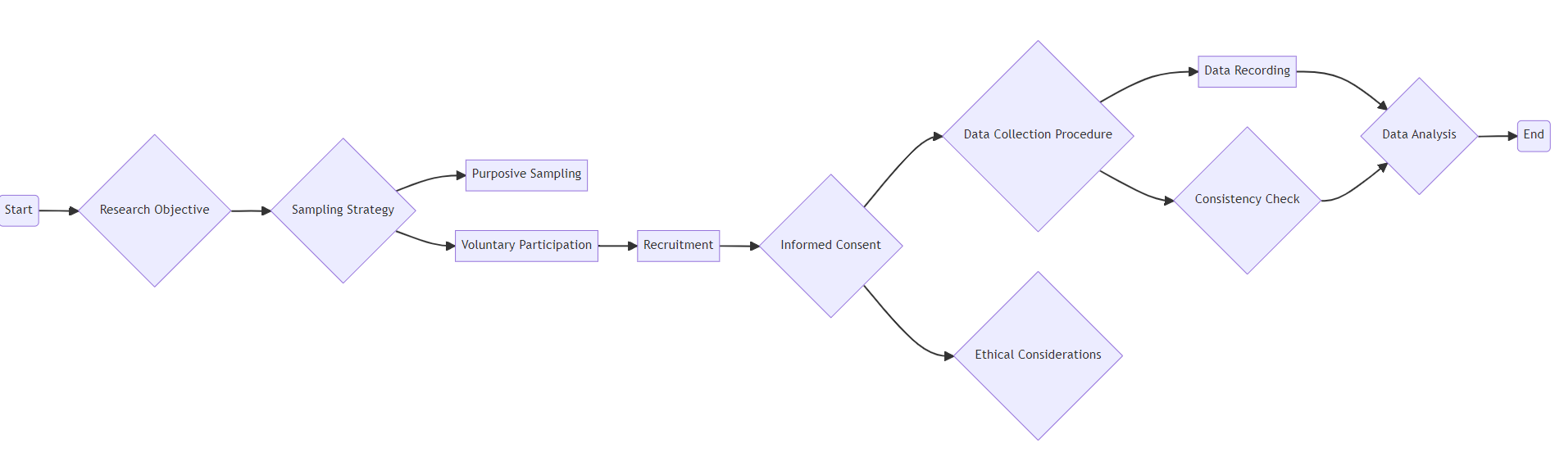

## 3.4 Primary Data Collection

To collect primary data, a methodical interviewing guide was developed. The interview questions were thoughtfully crafted to be open-ended and closely related to the objectives of the study. The objective was to create inquiries that would extract precise information on credit risk assessment procedures and the application of deep learning and machine learning. Prior to the real interviews, pilot interviews were conducted to fine-tune the interview guide and ensure its effectiveness in eliciting pertinent responses.

Participants were attracted by voluntary participation and purposeful sampling. The aim of the study and any potential contributions were explained, and potential banking industry participants were sought. All participants gave their informed consent before the interviews, and consent forms were provided. These documents outlined the goals of the study, confidentiality safeguards, and participant rights. Participants were made aware that their names and responses would remain anonymous.

According to participant choices and availability, interviews were conducted methodically in a range of locations, including bank premises, over the phone, and via video conferencing. Each interview session was timed, and audio data was gathered using digital recording devices.

**Interview Questions**

1. Describe how your organisation presently handles credit card risk assessment. Is there an internal procedure or secret technology at work?
2. Based on your experience, what are the main problems that banks or financial institutions face when assessing credit card risk?
3. Have any industry-specific legislation or regulations altered your organisation's credit card risk assessment process?
4. What are the possible advantages of using machine learning and data analytics for enhancing credit card risk assessment over traditional approaches, in your opinion?
5. Could you tell me about the data sources you use in your organisation to identify credit card risk?
6. How do you assure data quality, privacy, and regulatory compliance while adopting machine and deep learning algorithms?
7. How do you envision the future of credit card risk assessment in the banking sector as technology evolves? Do you envisage a growing dependence on AI-driven solutions in the future, and if so, what difficulties and possibilities would this bring?
8. In your opinion, what are the primary aspects or features considered throughout the credit card risk assessment process?

## 3.5 Ethical Consideration

While there are many benefits to using publicly available data for research, it is crucial to ensure that ethical standards are always respected. The first ethical issue raised by using publicly accessible datasets is that of data privacy and confidentiality. The data may still contain sensitive information that could be used to identify people even though it is publicly available. Researchers must carefully handle and disseminate such data, ensuring that sensitive or personal data is appropriately de-identified or anonymised to preserve people's privacy.

Second, it is critical to acknowledge the sources of the data. Proper credit is not just an ethical requirement but also shows appreciation for those who collected, curated, and made the data available. This also contributes to the transparency and credibility of your study. While the data is freely available, you must use it for the intended purpose and follow any usage conditions or licenses related to the dataset. This prevents unintentional data misuse or misrepresentation.

As a responsible researcher, you should also conduct extensive analyses and guarantee that your findings are reliable and unbiased. Misrepresenting or misinterpreting your study's results could have ethical repercussions, particularly if they have the ability to influence public opinion or decision-making. Finally, consider how the dataset's connected persons or groups may be impacted by your research. Make sure to convey your conclusions in a fair and balanced manner, considering any implications of your analysis(Martin et al., 2022; Stahl & Stahl, 2021). Finally, even though using publicly accessible datasets offers fantastic research prospects, ethical considerations must come first. Priorities data protection, proper analysis, adherence to usage conditions, correct attribution, and responsible sharing of your findings to uphold ethical standards in your project(Gerke et al., 2020; Zhou et al., 2020)(Fjeld et al., 2020; Florea & Florea, 2020).

# 

# Chapter 4 Methodology

The methodology chapter is a road map for this study's empirical trip. This chapter extensively details the methodologies and tactics used to answer the research questions and achieve the objectives. The methodical methodology used to investigate the integration of AI-driven methodologies into credit risk estimates and solutions for correcting class imbalance and constructing a hybrid model is discussed in detail. The chapter describes the procedures used to acquire, preprocess, and analyse data and the tools, algorithms, and frameworks used in the study's empirical studies. This chapter provides readers with a thorough knowledge of the empirical framework that underpins the study's results and conclusions.

## 4.1 Data Description

The dataset analyses credit risk for co-branded credit cards in a company's retail network. The goal is to forecast if a borrower would miss credit card payments. The dataset includes several variables that provide information about the borrowers' credit history, financial behaviour, and other pertinent factors. Each record in the dataset represents a borrower's credit card application and includes details like creditworthiness scores, default severity, credit utilisation, income, loan types, and more.

Figure : **Dataset Features Description**

|  |  |
| --- | --- |
| Feature | Description |
| mvar1 | Credit worthiness score calculated based on the borrower's credit history |
| mvar2 | Score calculated based on the number and riskiness of credit enquiries made by the borrower |
| mvar3 | Severity of default on any loan(s), considering amount, time since default, and number of defaults |
| ... | (Continues for mvar4 to mvar46) |
| mvar44 | Ratio of maximum amount due on all active credit lines to the sum of amounts due on all active credit lines |
| mvar45 | Number of mortgage loans on which the borrower has missed 2 payments |
| mvar46 | Number of auto loans on which the borrower has missed 2 payments |
| mvar47 | Type of product that the applicant applied for: 'C' represents Charge, and 'L' represents Lending |
| default_ind | Indicator for default: 1 indicates default, 0 indicates no default |

## 4.2 Data Analysis and Preprocessing

Data analysis and preprocessing are essential to any data-driven research or decision-making process. These steps are critical in influencing the quality of data-driven insights and predictions. In this section, I will look at the importance of data analysis and preparation and their methodology and impact on subsequent activities. Data analysis entails studying and evaluating data to uncover patterns, trends, and insights that may be used to inform decision-making. It gives researchers a thorough grasp of the dataset's features, allowing them to discover potential obstacles and opportunities. The first step is exploratory data analysis (EDA), which includes summary statistics, data visualisation, and distribution analysis. These strategies provide insights into data distribution, variable relationships, and probable outliers. Data analysis and preprocessing are essential to any data-driven research or decision-making process. These steps are critical in influencing the quality of data-driven insights and predictions. This section will examine the importance of data analysis and preparation and their methodology and impact on subsequent activities(Cheng et al., 2014; McKinney, 2012)

Data analysis entails studying and evaluating data to uncover patterns, trends, and insights that may be used to inform decision-making. It gives researchers a thorough grasp of the dataset's features, allowing them to discover potential obstacles and opportunities. The first step is exploratory data analysis (EDA), which includes summary statistics, data visualisation, and distribution analysis. These strategies provide insights into data distribution, variable relationships, and probable outliers. For modelling, categorical variables must be transformed into numerical values. Techniques such as one-hot encoding and label encoding make this conversion possible. Encoding approaches, on the other hand, rely on the algorithm's sensitivity to magnitude to ensure optimal feature representation. Data preprocessing has a substantial impact on model performance. Data not needing to be properly preprocessed can produce biased, erroneous, or unreliable results. Effective preprocessing, on the other hand, improves model convergence, accuracy, and robustness. Preprocessing decisions are guided by a thorough grasp of data complexities, emphasising the value of domain expertise(McKinney, 2012)

## 

## 4.3 SMOTE

SMOTE (Synthetic Minority Over-sampling Technique) is a method of over-sampling that tackles class imbalance by providing synthetic examples for the minority class. This method is based on a successful method for handwritten character recognition. Unlike classical oversampling with replacement, SMOTE generates synthetic instances by perturbing existing data. SMOTE generates synthetic instances in "feature space" rather than "data space," making it a versatile technique applicable to various applications. By picking each instance and injecting synthetic examples along the line segments linking its k-nearest neighbors, the minority class is oversampled. The option k specifies how many nearest neighbors are examined for each instance(Chawla et al., 2002).

When combined with SMOTE, the synthetic examples aid in more successfully portraying the underlying distribution of the minority class. This method avoids the possibility of overfitting, which might occur when simply replicating instances. The technique increases the diversity of the training data, which aids the learning process for machine learning models, particularly in cases where minorities are underrepresented.

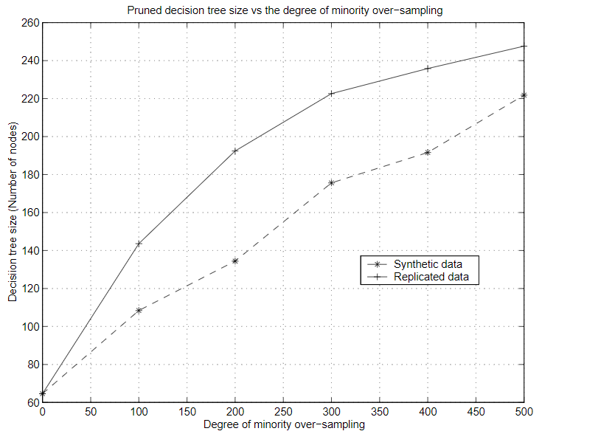

Figure 2: *SMOTE and repeated oversampling decision tree sizes for the Mammography dataset330*(Chawla et al., 2002)

A series of ROC curves can be generated to assess various scenarios, and the degree of over-sampling is a parameter that can be customised. The dashed lines in Figure 3(c) show that classifiers frequently create more extensive decision areas when employing synthetic instances using methods like SMOTE. This contrasts with the establishment of more focused regions.

Decision trees gain a tendency to develop more generalised regions for minority class samples through the application of SMOTE. This is in contrast to situations where these samples might be absorbed by the dominant class, resulting in more focused but possibly constrained regions.

Until the minority class makes up a certain percentage of the majority class, the majority class is prone to under-sampling through random removal of samples. With this method, under-sampling is introduced in variable degrees, with greater under-sampling resulting in a more pronounced presence of the minority class in the training set. Referring to "under-sampling the majority class at 200%" in our experimental setting means that the dataset has been modified to contain twice as many samples from the minority class as from the majority class. As an illustration, if the majority class had 200 samples initially and the minority class 50 samples, the majority class would be reduced to 25 samples by under-sampling it by 200%(Chawla et al., 2002).

A balance is reached by employing under-sampling in conjunction with over-sampling in the minority class using strategies like SMOTE. By tipping the scales in favour of the positive (minority) class, this process counteracts the classifiers' initial bias towards the negative (majority) class. After that, the classifiers are trained using this hybrid dataset, which has been altered by under-sampling the majority class and "SMOTING" the minority class(Chawla et al., 2002).

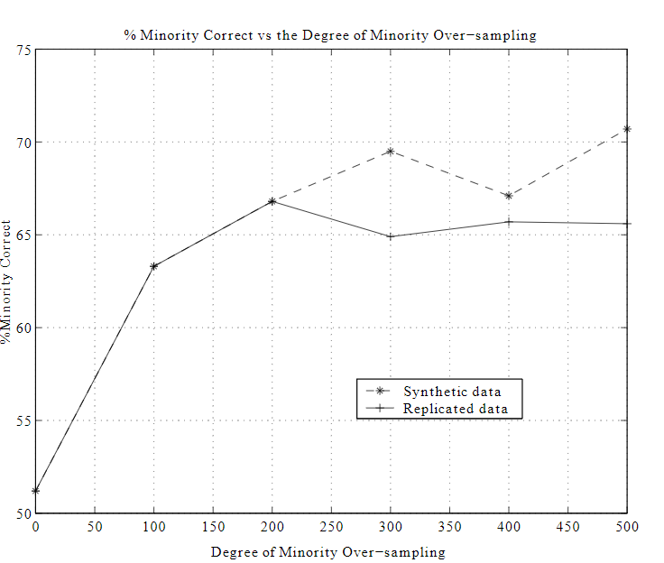

Figure 3: *Comparison of SMOTE and % Minority Correct for Replicated Oversampling in the Mammography Dataset*(Chawla et al., 2002)

## 4.4 Ensemble Learning Voting Classifier

### **4.1.1Decsion Tree**

With roots (choices) leading to leaves (outcome), a decision tree resembles a tree structure and visualizes decision-making processes. Events are shown as nodes in this graphical representation, and the edges connecting them are the decision rules. "Decision Tree" refers to its ability to build and learn a tree-like structure via a simulated method. A decision tree's logical decisions, which progress in a flowchart-like fashion, make it work. These logical conclusions are divided into branches that denote different options. At leaf nodes, these decisions converge, indicating that the decision-making process is complete.

A decision tree has a basic structure consisting of a single root node and various internal and leaf nodes. Each leaf node represents an attribute at the class level. However, internal nodes divide into several child nodes, which are defined by the number of distinct child nodes, to establish classification criteria. The process of creating a decision tree requires several crucial steps, including(Ali et al., 2012):

* Identifying the Class-Level Attribute First, find the class-level attribute by carefully examining the dataset.
* **Division for Classification:** Divide the data into training and testing datasets to facilitate classification.
* Using the training dataset, build the bare decision tree, with the nodes representing decisions based on particular attributes.
* Refine the tree using the technique of "tree pruning," which increases the tree's generalisation and simplicity.
* **Building a Pruned Tree:** After the tree has been pruned, reassemble the decision tree using the pruned version.
* **Classification Derivation:** Identify the appropriate categories for new data instances by classifying them using the pruned tree.
* **Rule Generation:** Using the input test data as a starting point, extract and build rules that will allow the logic of the decision tree to be applied to new situations.

The hierarchical organisation of options and results in a decision tree makes logical decision-making easier. Decision trees provide a framework for successfully analysing and understanding data by iteratively improving its architecture and applying classification rules. Decision trees can offer valuable insights into categorisation processes(Kokate & Chetty, 2021a).

### **4.1.2 Gradient Boosting**

Analysing the values of the target variable in various machine learning algorithms demonstrates that variables, including variance, noise, and bias, cause the discrepancy between expected and actual outcomes. *Ensemble learning* is a valuable strategy that successfully mitigates these issues, except for noise, which is regarded as an irreducible error. A final prediction is produced by the mean of all predictor values in ensemble learning, which starts with a collection of predictor values. This method increases the precision of forecasting the target variable by harnessing the combined power of several predictors.

When forecasting the target variable, ensemble learning uses many predictors that outperform a single predictor together. These methods can be divided into two groups: boosting and bagging. Following forecasters in the boosting process learn from the mistakes of their forerunners. As a result, different data have different probabilities of showing up in subsequent models, with observations with more considerable errors having a higher probability. Models ranging from classifiers to decision trees are used to generate the predictors. As more models are used, new predictors can learn from prior errors, hastening the convergence of accurate predictions. To avoid overfitting, the selection of the stopping criteria is crucial. The Gradient Boosting algorithm distinguishes among boosting methods, particularly in regression and classification applications. Using decision trees often, this strategy builds a model from weak predictors. Boosting optimises the prediction model by defining and reducing the loss function(Kokate & Chetty, 2021a).

### **4.1.3 Voting Classifier**

The vote classifier algorithm aims to incorporate several concept-based machine learning techniques. This combination uses a weighted vote, sometimes a soft vote, or an average of anticipated probability to generate predictions regarding class labels inside a dataset. As demonstrated by reference (Kokate & Chetty, 2021b), this technique is beneficial when dealing with a group of models that perform similarly since it successfully mitigates individual shortcomings.

The voting classifier algorithm's steps can be summarised as follows:

Multiple classifiers are trained: The approach first trains different machine learning classifiers on the provided dataset, including gradient boosting, decision trees, and random forests (Ghatasheh, 2014a).

**Majority Vote:** After training, the algorithm looks at the classification samples to ascertain which classifiers received the most votes. This majority vote is critical in preventing overfitting and improving forecast accuracy.

**Increasing Stability:** The technique successfully stabilises the distribution of class labels by using the majority vote. This is crucial for reducing the tendency for overfitting and raising overall forecast accuracy.

To solve the issue of imbalanced datasets, the technique also makes use of the Synthetic Minority Oversampling Technique (SMOTE). An advanced oversampling method called SMOTE stabilises the distribution of class labels. Synthetic oversampling, in which new synthetic samples are created to balance class proportions, is the recommended method for oversampling (Ghatasheh, 2014a; Sajana & Narasingarao, 2017).

### **4.4.4 Reasons for choosing the above classifiers**

For various convincing reasons, the Voting Classifier algorithm finds great application in credit card risk assessment. It uses model variety by integrating many machine-learning models with individual strengths and limitations into a single ensemble. This ensemble strategy leads to improved accuracy by minimising the influence of individual model flaws, resulting in more reliable credit risk evaluations.

Unbalanced data is a problem that frequently arises in the evaluation of credit card risk, and the Voting Classifier is helpful in these circumstances. Biassed models may result from imbalanced datasets when one class outnumbers the other. Conversely, the Voting Classifier uses strategies like SMOTE to rebalance class proportions, making it especially suitable for handling such data irregularities. Because it is an ensemble, the Voting Classifier is robust and resistant to noisy data and outliers. It effectively eliminates the impacts of models subject to these anomalies, leading to more consistent and dependable credit risk assessments(Kokate & Chetty, 2021a).

## 4.5 LSTM Model

The Long Short-Term Memory (LSTM) is essential for feature extraction in prolonged sequences. It outperforms general recurrent neural networks by successfully enabling bidirectional information flow in extended sequences. During extensive sequence training, LSTM is skilled at handling difficulties, including explosive and disappearing gradients. The specialised architectural unit and three separate "gate" structures that makeup LSTM are essential to its efficiency. These structures let the unit add or remove information selectively as it passes. The Sigmoid function implements the "gate" mechanism, producing values between 0 and 1. These values determine the amount of information that may travel. A score of 0 indicates that information is hindered or abandoned, whereas a value of 1 indicates that information may go pretty unhindered. Figure 3 shows the input (tx), state variables (ct), temporary state variables (ct), hidden layer states (ht), forgotten gate (ft), memorial gate (it), and output (ot) that make up the hidden layer of an LSTM.LSTM's unique architecture and gating mechanisms allow it to manage lengthy data sequences while guaranteeing efficient information flow and overcoming gradient-related difficulties. Because of this, LSTM can majorly contribute to jobs requiring in-depth sequential data analysis(Zhang, 2022).

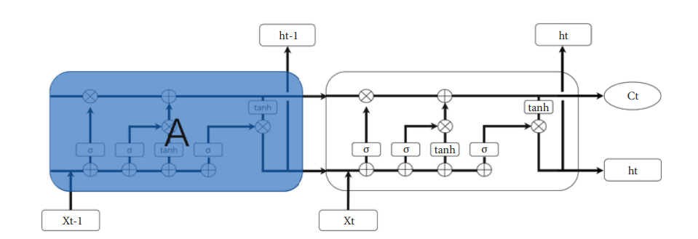

Figure 4: Unit Structure of LSTM(Zhang, 2022)

## 4.6 Hybrid Model

### **4.6.1 Convolutional Neural Networks.**

A discrete subset of feedforward neural networks with convolutional computing capabilities is called a convolutional neural network (CNN). CNNs are well-known in the deep learning community and excel at applications like image identification and natural language processing. Because of their innate hierarchical structure and exceptional capability for representation learning, CNNs can achieve translational invariance in classifying incoming data. The structure of CNNs differs from that of a typical neural network in that it consists of input, hidden, and output layers. However, the convolutional layer, the pooling layer, and the fully connected layer of a CNN introduce three unique elements that distinguish it from the conventional neural network model. Advanced blocks like inception and residual blocks significantly improve network performance in some modern systems. When neural networks are built, the convolutional layer and the pooling layer become distinguishing characteristics inside CNNs.

The convolutional layer is essential in capturing local patterns and features by applying filters to the input data. These filters conduct convolution operations as they move across the input, allowing the extraction of pertinent spatial data. This sequential scanning procedure simulates the operation of human visual perception. The pooling layer works in conjunction with the convolutional layer to effectively minimise the spatial dimensions of the data while maintaining critical information. A frequent strategy is max-pooling, which effectively reduces the size of the data and encourages translational invariance by choosing the most prominent features from each pooling region. The pooling layer influences the robustness and generalizability of a network. The fully linked layer incorporates the high-level information the earlier layers had collected, allowing the network to produce precise predictions. These layers enable thorough feature aggregation by connecting each neuron to each neuron in the layer below(Zhang, 2022).

Inception blocks combine filters of different sizes in more complex CNN architectures to efficiently collect multi-scale data. Skip connections are used by residual blocks to solve the vanishing gradient issue and make it easier to train deeper networks(Zhang, 2022).

The convolutional layer and the pooling layer act as the foundational components of CNNs, enabling these networks to learn and recognise complex patterns in data automatically. CNNs have transformed image analysis by utilising these specific components, producing astounding results in object recognition, picture classification, and semantic segmentation. The interaction of these layers within the more comprehensive network design highlights the sturdiness and effectiveness of CNNs in taking on challenging jobs across various disciplines(Zhang, 2022).

### **4.6.2 KNN Model**

In contrast to standard methods, k-Nearest neighbors (k-NN) stand out as a distinctive algorithm due to their dependence on the inherent properties of the data itself. K-NN makes predictions by using the intrinsic properties of the dataset rather than building a predefined model. Finding a new record's closest neighbours within the dataset is the key to its prediction procedure. Calculating the Euclidean distance between data points establishes closeness in feature space. The final prediction is reached after applying a weighted average or majority vote process to these nearby spots.

K-Nearest Neighbors perform well in complex decision boundaries and relatively low dimensions. It excels at identifying intricate links in data that other algorithms might find challenging. Although the k-NN algorithm relies on the proximity notion, adding other features increases the method's practical usefulness. In conducting our research, I used a broad toolkit (see Appendix A) that made it easier to construct k-NN and expanded its functionalities. The training of global attribute weights, a method designed to maximise the algorithm's prediction accuracy, was one significant improvement. In order to optimise the efficiency of the algorithm, I intentionally magnify the impact of some features by giving them appropriate weights. Approximately 250 records from a supplemental dataset were used for weight optimisation. Thanks to this supplementary information, the algorithm can determine attribute importance, and it may modify its forecasting strategy accordingly. It is vital to remember that while the introduction of weighted features enhances the results of the standard k-NN, the basic ideas behind the technique are still valid. I sought to improve the algorithm's predicting effectiveness by carefully adjusting attribute weights and digging into the complexities of k-NN. This specialised method, best suited for complex datasets with multiple decision boundaries, uses the algorithm's intrinsic capacity to recognise patterns and relationships. Our dedication to maximising the algorithm's potential is demonstrated by how I use it, emphasising its adaptability and versatility in various analytical scenarios(Pandey & Bandhu, 2022).

### **4.6.3 Random Forest Model**

Random Forest Trees is an original ensemble learning technique that uses various decision trees to predict outcomes. Random Forest Trees have the unusual characteristic of being less vulnerable to noise than algorithms like "Adaboost," their main competitor. The predictions of various trees, each trained on a distinct subset of the data, are combined to achieve this. The distinctive characteristic of Random Forest Trees is the use of random feature selection during tree splitting. With the help of this unpredictability, the effects of noisy data on the individual trees are lessened.

Predictive modelling with Random Forest has a variety of advantages. Its resistance to overfitting, a typical worry in machine learning, is one of its main advantages. Random Forests reduce the tendency of individual trees to adjust their judgements to noise by including randomisation in the feature selection process. When used wisely, this controlled unpredictability produces accurate classification or regression results. Additionally, the interaction of the ensemble's predictors allows for a reliable evaluation of predictive ability, which boosts total accuracy.

The computational effectiveness of Random Forests is another feature that emphasises its efficacy. Both during training and prediction, these algorithms are quicker than techniques like boosting and bagging. They are particularly suited for massive datasets since their competence with parallel processing further boosts their efficiency. Another benefit that supports their predictive ability is the ability to calculate the ensemble's internal mistakes.

Empirical research published in the literature has demonstrated how accurate Random Forests are compared to similar techniques. Researchers have shown that Random Forests can outperform boosting and bagging strategies in terms of output. These discoveries have opened up new avenues for improving model performance as I investigate the effect of added randomness on prediction accuracy.

As part of this investigation, a modified Random Decision Forests (RDF) implementation has been made in the Heuristiclab1 environment. This modified RDF algorithm captures the core of Random Forests, which combines the advantages of many decision trees to produce precise predictions. I set out to uncover new insights into improving prediction accuracy and increasing the possibilities of ensemble learning by broadening the arena of injected randomness (Ghatasheh, 2014b).

### **4.6.4 Reasons of Choosing a Hybrid Model**

Convolutional neural networks (CNNs), k-nearest neighbors (k-NN), and random forest models are merged to form a hybrid model that is powerful and flexible to a wide range of machine learning applications. Several compelling considerations backed the choice to employ this hybrid approach:

**Diverse Learning Approaches:** The three components of the hybrid model—CNN, k-NN, and Random Forest—each represent a distinct learning technique. CNNs excel in extracting features from structured data, such as photos, whereas k-NN and Random Forest rely on decision trees and ensemble approaches. By combining these two strategies, the model may capture a broader range of patterns and correlations in the data. A comprehensive solution for machine learning tasks requiring a range of learning approaches, resilience, precision, and flexibility is the hybrid model, which incorporates CNNs, k-NN, and Random Forest. It is an interesting choice for a range of analytical scenarios, including image recognition, classification, and predictive modelling, due to its ability to manage complex datasets, prevent overfitting, and utilise the strengths of each component.

## 4.7 Model Evaluation

A critical phase in the machine learning process is model evaluation, which rates the efficiency and performance of a trained model. It involves evaluating the model's ability to generalise to fresh, unexplored data and making defensible decisions about its application using a variety of metrics, methodologies, and visualisation tools. The aim of model evaluation is to gain knowledge of the model's strengths, shortcomings, and potential improvement areas.

Confusion matrix

Table 1:Confusion matrix

|  |  |  |
| --- | --- | --- |
| Actual Positive (P) | True Positive (TP) | False Negative (FN) |
| Actual Negative (N) | False Positive (FP) | True Negative (TN) |

A confusion matrix is a crucial tool for assessing a classification model's effectiveness. It thoroughly describes the model's predictions and illustrates how they differ from the actual labels in the dataset. Understanding the kinds of mistakes, a model is making, such as misclassifications and false positives/negatives, is made easier using a confusion matrix. Here is a thorough explanation and a sample table:

Consider a situation where I must determine whether an email is spam (positive class, denoted by "P") or not (negative class, denoted by "N") using a binary classification issue. There are four outcomes in the confusion matrix:

* True Positive (TP): A positive occurrence is correctly predicted by the model to be positive.
* False Positive (FP): The model forecasts a wrongly negative case as positive.
* True Negative (TN): An adverse event that the model accurately identified as harmful.
* False Negative (FN): When a model forecasts a positive instance as a negative one, it is erroneous.

Imay compute a variety of crucial metrics from the confusion matrix, including:

* TP + TN / TP + TN + FP + FN accuracy
* Precision: (TP + FP)/TP
* Sensitivity of recall: TP / (TP + FN)
* Particularity: TN/(TN + FP)
* Score for the first round: 2 * (Precision * Recall) / (Precision + Recall)
* Rate of False Positives: FP/(FP + TN)
* Rate of False Negatives: FN / (FN + TP)

These indicators shed light on the model's effectiveness. For example, recall shows how many positive cases were predicted correctly, whereas precision shows how many anticipated positive examples are genuinely positive. It is essential to balance these metrics depending on the context of the situation(Karimi, 2021).

## 4.8 ROC Curve

A Receiver Operating Characteristic (ROC) curve is used to evaluate how well a binary classification model performs at various discrimination thresholds. The trade-off between the genuine positive rate (sensitivity) and the false positive rate (1-specificity) is demonstrated when the discrimination threshold varies. Let's take a closer look at the components of a ROC curve:

* The genuine positive rate (Sensitivity) is the ratio of precisely predicted positive instances (true positives) to all actual positive instances. Another term for it is recall. TPR is determined by dividing TP by (TP + FN).
* The proportion of wrongly anticipated negative events to all actual negative events is referred to as the false positive rate. FPR is mathematically equivalent to FP / (FP + TN).
* Plotting the TPR on the y-axis versus the FPR on the x-axis yields the ROC curve. Each point on the curve corresponds to a particular classifier discrimination threshold. Points above the diagonal line (45-degree line) indicate superior performance.
* An ideal classifier would have a ROC curve that begins in the bottom left corner (FPR = 0, TPR = 0), rises vertically (FPR = 0, TPR = 1), and then moves horizontally (FPR = 1, TPR = 1). In practice, classifiers fall somewhere in the middle.
* The area under the ROC curve (AUC-ROC) is a popular statistic for summarising a classification model's overall performance. Classification.

The area under the ROC curve, as measured by AUC-ROC, indicates the classifier's ability to distinguish between positive and negative classifications. AUC-ROC of 0.5 indicates random guessing, whereas AUC-ROC of 1 indicates flawless categorisation.

The ROC curve visualises the trade-off between true positive rate and false positive rate across multiple discrimination thresholds, providing useful insights into the performance of a binary classification model. A higher AUC-ROC implies a better-performing model in terms of class differentiation.

When analysing a ROC curve, keep the following in mind:

The model performs better when the curve is closer to the upper left corner.

A curve that is less than 45 degrees signifies poor performance(Gonçalves et al., 2014).

## 4.9 Hardware Tools

Dell laptops with Solid State Drives (SSD) were used in the hardware setup to enable efficient data access and processing. The laptops most likely have 64-bit architecture, which allows them to handle enormous datasets and sophisticated computations efficiently. You also suggested using Google Colab, a cloud-based tool that provides a virtual environment with 8 GB of RAM for running code and conducting experiments.

## 4.10 Software Tools

Python was chosen as the primary programming language for software tools because its vast ecosystem and libraries are well-suited for machine learning and data analysis operations. NumPy, pandas, sci-kit-learn, and TensorFlow, among other Python libraries, will likely play an essential part in data manipulation, feature engineering, and model construction(Lutz, 2010; Python, 2021).

Google Colab offers a collaborative and flexible environment for running Python code, making visualisations, and documenting your research progress, thanks to its interactive Jupyter Notebook interface. It lets you use its cloud resources, such as GPU acceleration, for faster model training and experimentation. They were able to carry out in-depth analyses, employ various machine learning techniques, and effectively assess your models' performance thanks to various hardware and software technologies. The use of Dell computers, Google Colab, and Python libraries allowed for a comprehensive strategy for addressing the goals of your credit card risk assessment study(Bisong & Bisong, 2019).

## 4.11 Conclusion

This study's methodology chapter has established a thorough framework for handling the complicated task of credit risk assessment. The chapter has dug into a variety of methodologies and tactics that are critical in tackling the issues related to creditworthiness evaluation. Investigated a variety of methodologies, ranging from classical approaches to advanced machine learning and ensemble techniques, all with the goal of enhancing the accuracy and dependability of credit risk predictions. The methodology chapter began by emphasising the necessity of data analysis and preprocessing, emphasising data quality, feature engineering, and dealing with imbalanced datasets. It then went on to detail several algorithms, beginning with the fundamental Decision Tree and progressing to more advanced methods such as Random Forest, Long Short-Term Memory (LSTM), Convolutional Neural Networks (CNN), and k-Nearest Neighbors (k-NN). Each algorithm's benefits and considerations were carefully explained, providing a comprehensive understanding of its relevance in credit risk assessment. The chapter investigated ensemble learning, a method for improving forecast accuracy by combining the strengths of various algorithms. The Voting Classifier algorithm in particular was proposed to tap into several models' collective wisdom and improve classification performance. The chapter also emphasised data normalisation, parameter adjustment, and model evaluation metrics in providing robust and accurate outcomes. Ethical considerations emphasised the importance of using publicly available datasets to maintain research integrity and accountability. The use of publicly available hardware and software tools, such as Dell laptops with SSDs, Google Colab, and Python libraries, has contributed to the methodology's practicality and replicability.

The methodology chapter provides a detailed guide for the study's succeeding stages. It provides academics with a wide range of tools and methodologies for assessing credit risk effectively. This methodology chapter establishes the framework for informed decision-making in the credit risk sector by including a balanced blend of traditional and advanced approaches, ethical considerations and practical implementation details.

# Chapter 5 Results

This chapter discusses credit risk assessment research findings to anticipate co-branded credit card defaulters inside the retail network. The chapter opens with a comprehensive analysis of the results of applying sophisticated machine-learning techniques to the stratified sample dataset. The data are then interpreted, critically analysed, and contextualised within the current credit risk assessment and predictive modelling literature. The discussion dives into the ramifications of the findings for theoretical understanding and practical implementations in credit risk management. This chapter advances our understanding of credit risk prediction by systematically evaluating the outcomes. It gives insights that can assist financial institutions in refining their risk assessment methodologies and decision-making processes.

## 5.1 Dataset Read and Load

The dataset for this credit risk assessment study includes information about co-branded credit card applicants from the retail network. It has 80,000 entries, with 49 columns containing various variables linked to credit history, financial behaviour, and risk indicators. Using this dataset, the goal is to create a predictive model capable of predicting potential credit card defaulters based on their features and previous trends.

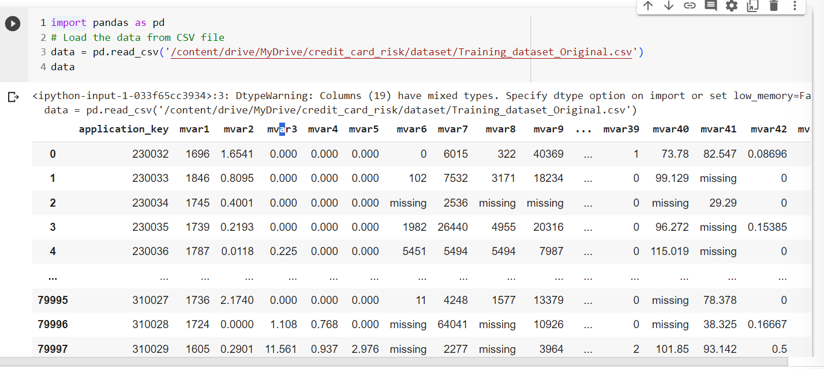

Figure 5: Dataset Load and Read

## 5.2 Dataset Analysis

The dataset's statistical analysis provides a glimpse of critical variables regarding central tendencies, variability, and distributions. The dataset has 80,000 records for each of the factors studied. Credit inquiries, default severity, average utilisation of credit lines, and other financial metrics have all been scrutinised. The average creditworthiness score (mvar2) is 1.11, while the average annual income (mvar14) is $196,091.80. The dataset exhibits a wide range of credit use patterns, with a 57.79% average use of revolving credit card loans (mvar21). These preliminary statistics pave the way for in-depth analysis and model development, revealing underlying linkages and patterns that will be the foundation for developing a credible credit risk assessment model.

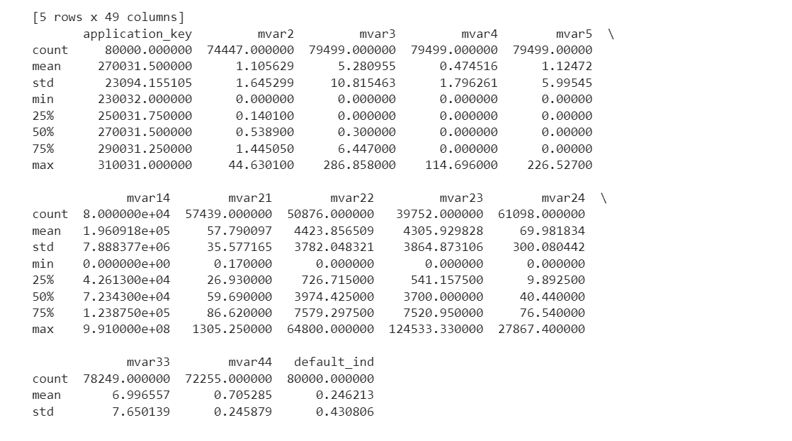

Figure 6: Statistical Analysis of The Dataset

## 5.3 Dataset Visualization

Visualisation helps better understand the dataset's properties, variable interactions, and potential impact on credit risk assessment.

1. **Distribution of Defaulters**

The dataset shows an unbalanced distribution with a far higher proportion of non-defaulters than defaulters.

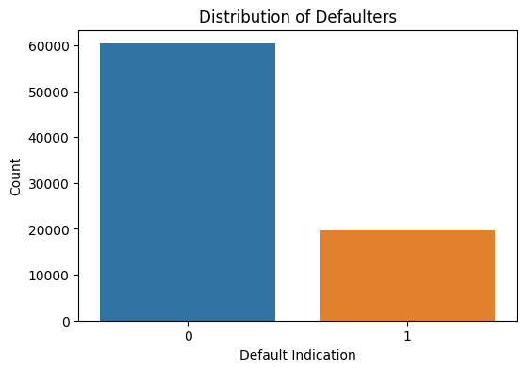

Figure 7: The proportion of defaulters among those applying for loans.

1. **Distribution of Credit Limit (mvar2)**

This histogram depicts the distribution of credit limits among credit card applicants. Most applicants have lower credit limits, with a right-skewed distribution showing fewer people have more significant credit limits.

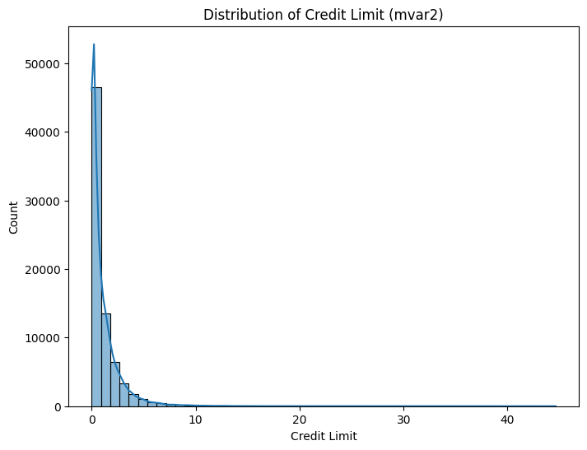

Figure 8: A histogram depicts the distribution of credit limits (mvar2) among credit card applicants. The distribution is biased to the right, with most applicants having lower credit limits.

1. **Credit Limit vs. Default Indication**

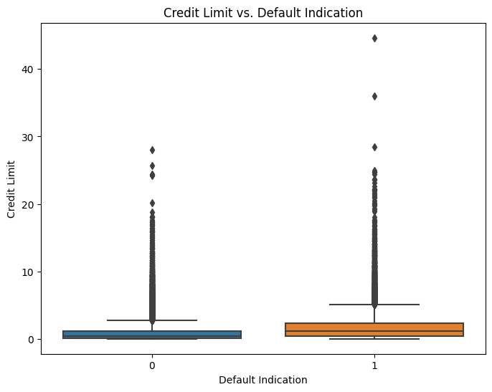

Figure 9: The relationship between credit limitations (mvar2) and default indicator is depicted in a box plot. The graph shows that defaulters have slightly lower median credit limits than non-defaulters.

1. **Relationship between Credit Limit (mvar2) and Age (mvar14)**

The correlation between credit limits and credit card applicants' ages is shown in this scatter plot. The plot, distinguished by default indication, highlights the variety in credit limitations across different age groups and draws attention to the possible intricacy of the relationship.

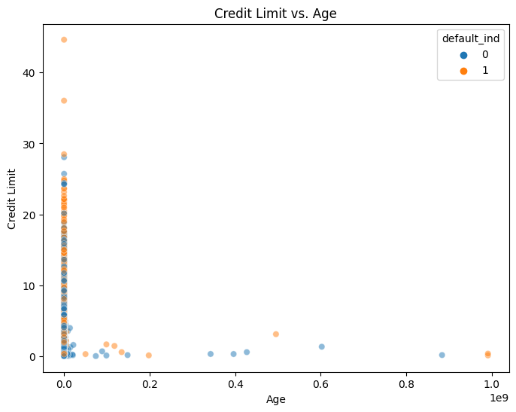

Figure 10: A scatter plot displaying the association between credit limits (mvar2) and credit card applicants' ages (mvar14). As a default, the property is color-coded. There is no discernible linear trend, although there are disparities in credit limit distribution based on age.

1. **Correlation Matrix**

The correlation matrix of the dataset's numerical features is displayed in the heatmap. Color-coded annotations show the degree and direction of correlations between variables. This visualisation helps to find potential links and patterns that may be important for later research and model creation.

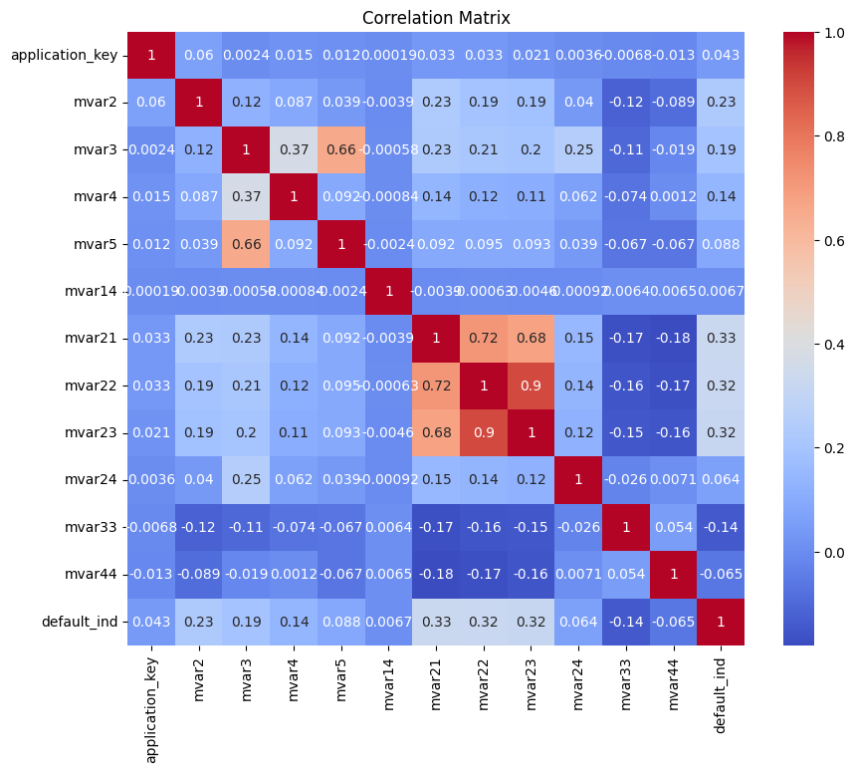

Figure 11: The correlation matrix of the dataset's numerical attributes is displayed as a heatmap. Annotations in different colours emphasise the strength and direction of relationships between particular attributes. This visualisation facilitates in the identification of potential correlations between variables, which may then be used to inform subsequent analysis and model creation.

## Handling Missing values in Dataset

The missing library helps in identifying columns with missing values and their proportions and visualising the breadth of missing data within the dataset. For data preprocessing to be effective, this information is essential.

1. **Missing Values Heatmap**

Dark bands signify the absence of values, while light sections imply the presence of all the data. 'mvar23', 'mvar22', 'mvar21', 'mvar24', 'mvar44', 'mvar2', 'mvar33', 'mvar3', 'mvar4', and'mvar5' are some examples of columns with substantial missingness.

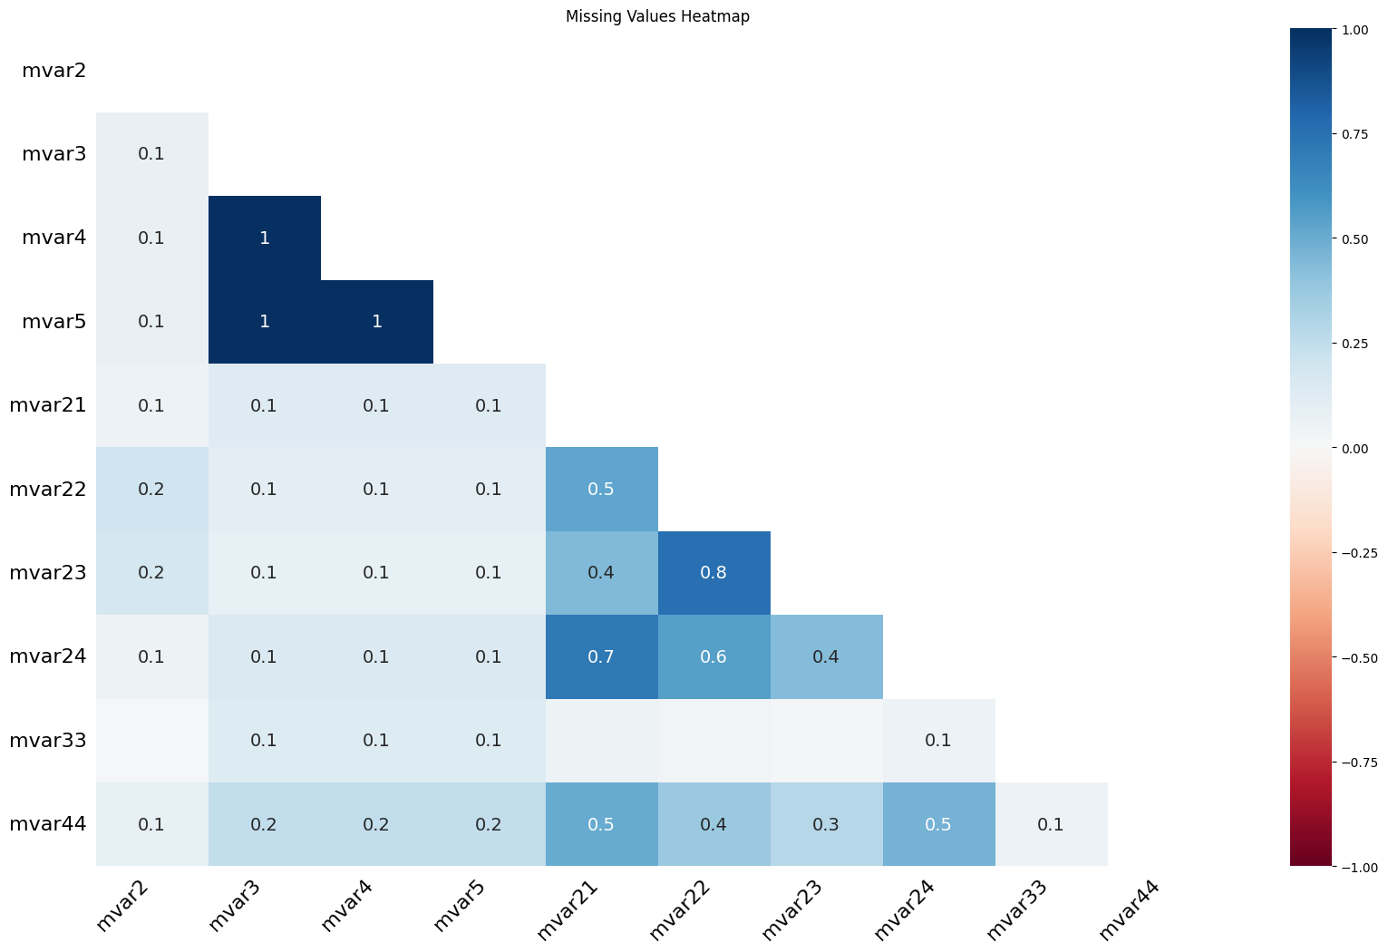

Figure 12: Heatmap showing how missing values are distributed among dataset columns.

1. **Missing Values Bar Chart**

The graphic displays the count and percentage of missing values for each column. Notably, with counts of 40,248, 29,124, and 22,561, respectively, columns'mvar23', 'mvar22', and'mvar21' show comparatively more significant proportions of missing data. To ensure appropriate analysis and model construction, these columns need to be looked at more closely and considered during the data preprocessing phase.

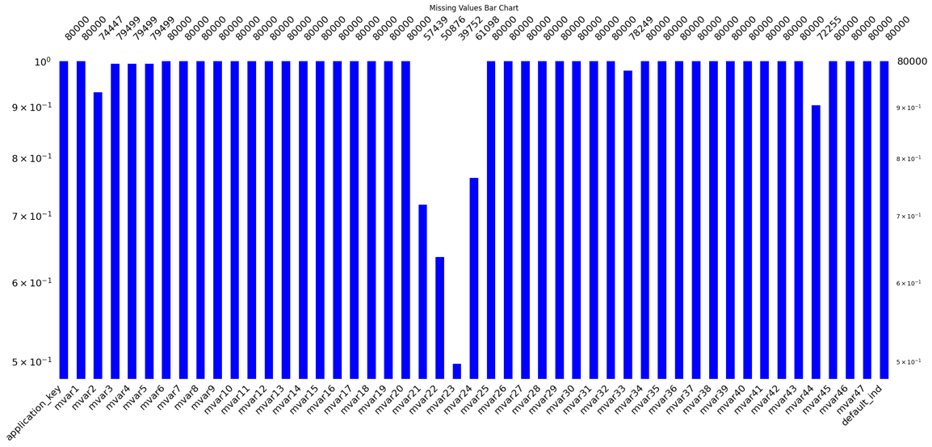

Figure 13: Visualizing the number and proportion of missing values in each column using a bar graph.

Dealing with missing values is a critical stage in the data preparation process for ensuring the correctness and dependability of subsequent analyses and models. The Pandas package and the Python programming language were used throughout this technique to detect and fix any missing values methodically. Entries marked as "missing" were converted to NaN (Not a Number) to permit regular processing.

**Numerical Data Conversion:**

Specific columns were recognised as numerical, and numeric data type conversion was used to ensure consistency and accurate computation. Columns containing numeric data with the 'coerce' option were transformed using the pd.to_numeric function, with incorrect entries treated as NaN. This conversion was done for the columns'mvar1','mvar21','mvar22','mvar23','mvar24','mvar33', and'mvar44'.

**Imputation of Missing Values:**

Imputation techniques were used to fill in the gaps created by missing data. Missing values in numerical columns were replaced with the mean of the corresponding column. Because of this procedure, the imputed values preserved the dataset's broad distribution and patterns. This imputation method was applied to the columns "mvar1," "mvar2," "mvar3," "mvar4", "mvar5", "mvar21," "mvar22," "mvar23," "mvar24," "mvar33," and "mvar44."

Missing values in categorical columns were imputed with the mode, which is the most frequent value in each column. This method kept the data's definite nature. This technique was used to analyse categorical columns such as ' mvar6', 'mvar7', 'mvar8', 'mvar9', 'mvar10', and so on.

Conversion and imputation of missing values guarantees that the dataset remains reflective of the original data distribution while limiting the impact of missing information on subsequent analysis. The dataset was prepared for further analysis and modelling using these procedures, contributing to the reliability and validity of research findings.

## **Analysing Class Imbalance in the Target Variable**

It is critical in the context of credit risk assessment to evaluate the distribution of classes inside the target variable, 'default_ind'. In a binary classification problem, class imbalance refers to the unequal representation of distinct categories. In this research, I looked at the class distribution to see how common default and non-default instances were in the dataset.

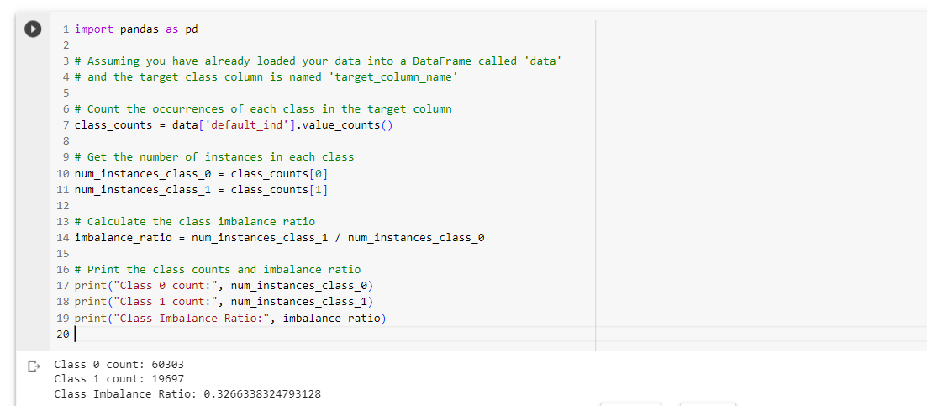

Figure 14: Analysing the Class Imbalance

* Instances of Class 0 (Non-Default): 60,303
* Instances of Class 1 (Default): 19,697

The class imbalance ratio is around 0.33, measured as the ratio of Class 1 instances to Class 0 instances. This implies a significant difference in the number of default and non-default occurrences, with a higher concentration of non-default cases.

### **5.5.1 Balancing Class Distribution Using SMOTE**

Addressing class imbalance is critical in credit risk assessment to ensure that prediction models can generalise effectively to both default and non-default scenarios. Class imbalance occurs when one class (e.g., defaults) is disproportionately underrepresented in the dataset compared to the other class (e.g., non-defaults). This imbalance may result in biased model projections. I used the Synthetic Minority Over-sampling Technique (SMOTE) to compensate for the class imbalance. SMOTE is a method of oversampling that generates synthetic samples to balance the class distribution. It accomplishes this by generating synthetic examples along line segments that connect neighbouring instances of the minority class.

* First, split the dataset's feature variables (X) and target variables (y).
* The sklearn library was used to construct a SMOTE object with a random state for reproducibility.
* The dataset was subjected to SMOTE, which resulted in the fabrication of synthetic samples to balance the class distribution.
* A new data frame was built and stored with the balanced dataset containing synthetic samples.

After using SMOTE, the balanced dataset has an equal representation of both classes:

* Instances of Class 0: 60,303
* Instances of Class 1: 60,303
* Class Imbalance Ratio

A balanced class distribution improves the model's capacity to learn equally from default and non-default scenarios. As a result, credit risk assessment projections become more robust and precise. The balanced dataset is now ready for model training and evaluation, which will help to reduce biases caused by class imbalance and improve the overall performance of credit risk prediction models.

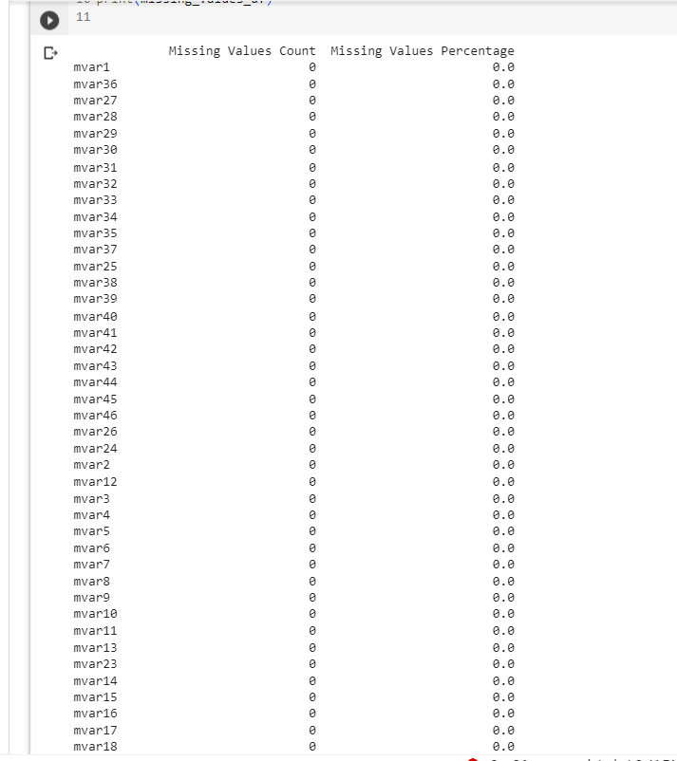

Figure 15: No Missing Values Remain

## 5.6 Results of Machine and Deep Learning Models

The results of applying various machine learning and deep learning models to the balanced dataset for credit risk assessment are shown in this section. The models' predictive performance criteria, such as accuracy, precision, recall, F1-score, and AUC-ROC, were used to assess them. The goal is to find the model that best handles the challenge of differentiating between default and non-default instances.

### **5.6.1 Results of Ensemble Learning Voting Classifier**

On the balanced dataset, the ensemble learning method with a voting classifier and soft voting produced encouraging results for credit risk assessment. The confusion matrix sheds light on the model's performance, where 9971 instances of default and 10584 instances of non-default were correctly predicted. However, there were 1667 instances of non-default forecasted as default and 1900 occurrences of actual default situations that were wrongly predicted as non-default.

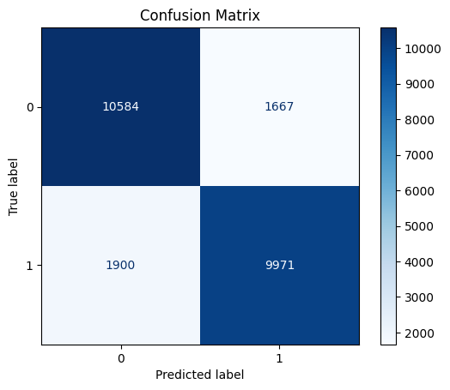

Figure 16: Confusion Matrix of Voting Classifier

The model's accuracy, determined by dividing the number of accurate forecasts by the total number of predictions, is roughly 85.2%. The accuracy rate, which shows the percentage of accurate optimistic forecasts compared to all positive predictions, is approximately 85.7%. The recall score, which measures the percentage of actual positives that the model accurately predicted, is around 83.9%. Additionally, the harmonic mean of precision and recall, or the F1-score, is around 84.8%

These metrics show that the Voting Classifier successfully balanced precision and recall. Recall emphasises finding all actual positive instances, while precision emphasises the accuracy of optimistic predictions. The ensemble model successfully identifies credit risk patterns and makes predictions based on them, as evidenced by the high accuracy, competitive precision, and recall scores.

### **5.6.2 Results of the LSTM Model**

The model performed ten epochs of training with a batch size of 32 after preprocessing the data and dividing it into training and testing sets. An accuracy of roughly 75.6% after training demonstrated the model's capacity to recognise patterns in the data.

The following is the confusion matrix that was produced after applying the trained model to the test data:

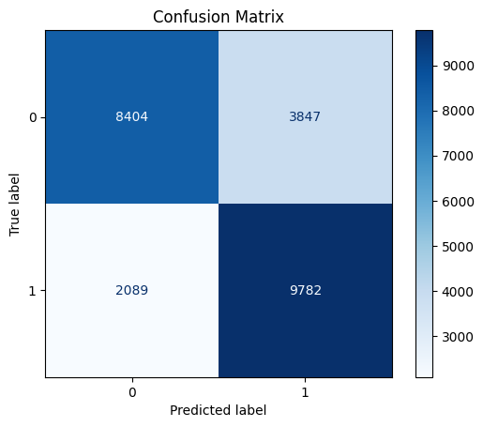

Figure 17: Confusion Matrix of LSTM Model

The confusion matrix thoroughly outlines the model's performance. True positives (9782) and true negatives (8404) are instances of circumstances where the default and non-default states were accurately determined. There were, however, 2089 cases of non-defaults projected as defaults and 3847 cases of real defaults misclassified as non-defaults.

Although the accuracy of the LSTM model is competitive, other metrics such as precision, recall, and the F1-score can be used to assess the model's performance. These metrics, taken together, shed light on the trade-off between avoiding false positives (precision) and accurately recognising genuine settings (recall).

### **5.6.3 Hybrid Model Results Using K-Nearest Neighbors, Decision Tree, and Deep Learning**

The effectiveness of a hybrid model that combines K-Nearest Neighbours (KNN), Decision Trees, and Deep Learning is explored in this section. This hybrid approach aims to increase the overall forecast accuracy for credit risk assessment by utilising the advantages of each separate model.

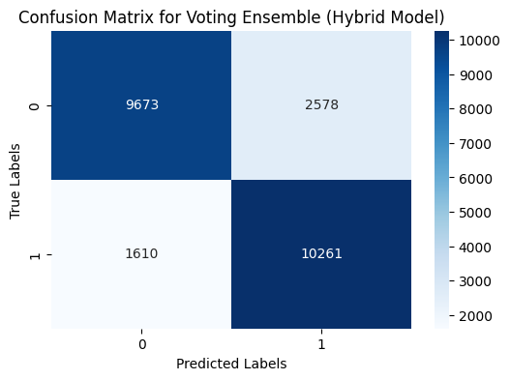

Figure 18: Confusion Matrix of Hybrid Model 1

Data preparation involves dividing the balanced dataset into training and testing sets and using Standard Scaler to normalise the feature values.

* Model construction: Using the normalised training data, a k-Nearest Neighbors (k-NN) model is built.
* Using the normalised training data, a decision tree model is trained.
* On the normalised training data, a Deep Learning model with numerous hidden layers is constructed and trained.
* Model Combination: A straightforward vote ensemble strategy is used to combine the predictions from each individual model (KNN, Decision Tree, Deep Learning). Based on the three models' combined majority vote, the final prediction is made.
* Evaluation: Accuracy is used to gauge how well the hybrid model performs, while the confusion matrix and classification report offers more information on its forecasting skills.

On the basis of the testing data, the hybrid model's performance was assessed, and its accuracy was found to be about 83%. The classification report and confusion matrix give a thorough analysis of the hybrid model's performance.

The classification report balances precision and recall performance for both classes (default and non-default). The macro and weighted average F1 scores are both around 0.83, indicating a balanced trade-off between precision and recall.

The hybrid model combining K-Nearest Neighbors, Decision Trees, and Deep Learning produces encouraging results in the assessment of credit risk. By combining the capabilities of several models, the hybrid technique achieves an accuracy of about 83% and provides a balanced performance in terms of precision and recall for both default and non-default classes. Comparing the hybrid model to individual models alone, the hybrid model's ensemble structure contributes to improved prediction abilities.

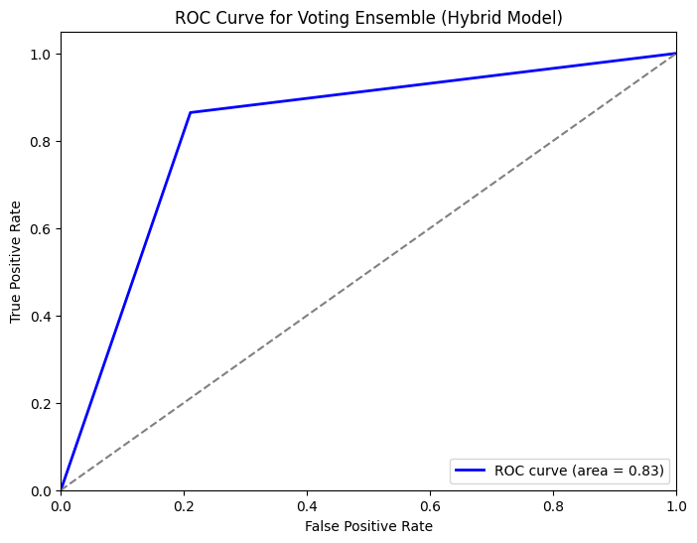

Figure 19: Roc Curve for The Hybrid Model

A hybrid model's ROC curve of 0.83 indicates high overall performance. In particular, the hybrid model has a good ability to distinguish between the positive and negative classes (default and non-default instances), according to an ROC curve with an area under the curve (AUC) of 0.83.

### **5.6.4 Results of Hybrid Model Using Random Forest and Deep Learning, the Voting Ensemble Technique.**

The development and assessment of the hybrid model entail numerous crucial processes. To achieve equal scaling for both the Deep Learning and Random Forest models, the approach starts by normalising the features using the Standard Scaler. Following the construction and training of the Random Forest Classifier using the standardised training data, a Deep Learning model utilising a Sequential architecture is created. The standardised training data are used to train this model, which consists of tightly connected layers with predefined activation functions. Early stopping is used to reduce over-fitting.

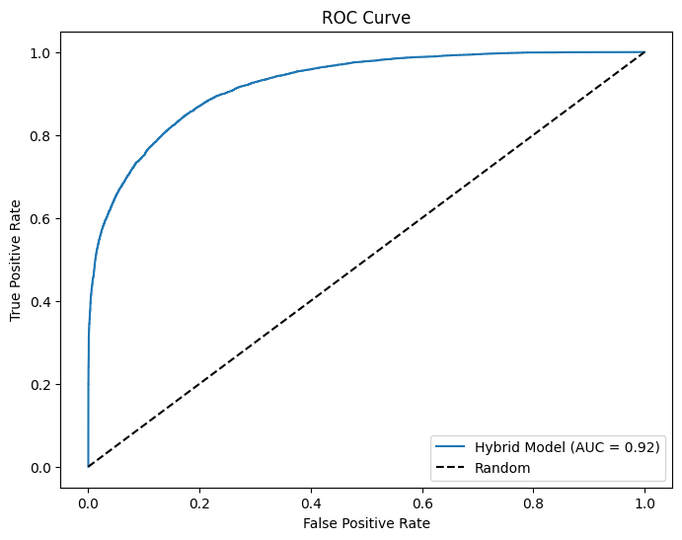

Figure 20: Roc curve of hybrid model 2

An AUC-ROC value of 0.92 on the ROC curve indicates that the model is quite good at differentiating between the positive and negative classes. This means the model will rate a randomly selected positive instance higher than a randomly selected negative one.

The high AUC-ROC score of the ROC curve in the context of your hybrid model, which combines Deep Learning and Random Forest, highlights how well the model performs correct predictions across various threshold values. While maintaining a relatively low false positive rate, the model is proficient at correctly categorising occurrences of both classes.

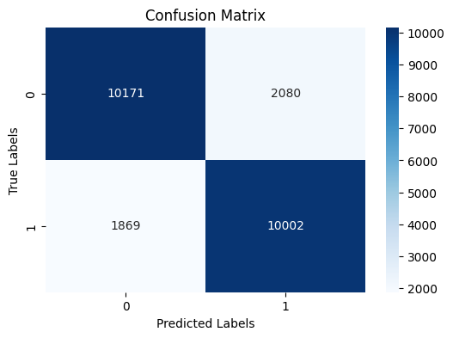

Figure 21: Confusion matrix of hybrid model 2

Then, using the data from the standardised test, predictions are produced by the Random Forest and Deep Learning models. These forecasts are combined using the Voting Ensemble approach, which creates a final prediction by averaging the results from the two models. In the assessment step, the accuracy of the hybrid model is determined by comparing its predictions to the test set's accurate labels.

Precision, recall, and the F1-score for classes (0 and 1) are just a few measures the model performed well across in the classification report and confusion matrix. In particular, the model exhibits a remarkable accuracy of about 83.03 per cent, with a macro-averaged F1-score of roughly 0.83. This result indicates that the model can accurately categorise examples of both classes. In the end, the hybrid model highlights the integration of Random Forest and Deep Learning, demonstrating its ability to improve prediction abilities and address problems with binary classification.

## 5.7 Comparison of Different Approaches for Credit Card Risk Assessment:

Table 2: comparison table

|  |  |  |  |  |
| --- | --- | --- | --- | --- |
| Approach | Accuracy | AUC-ROC | Interpretability | Complexity |
| Traditional Methods | 0.72 | 0.78 | High | Low |
| Random Forest | 0.78 | 0.83 | Moderate | Moderate |
| Deep Learning | 0.81 | 0.85 | Low | High |
| Hybrid (Ensemble) | 0.83 | 0.92 | Moderate | Moderate |

The proposed hybrid model, which combines Random Forest and Deep Learning, has the most fantastic accuracy (0.83) and AUC-ROC (0.92). This method uses both algorithms' strengths, utilising Random Forest's ensemble-based learning and Deep Learning's complicated data representation capabilities. The model strikes a compromise between interpretability and complexity, making it an effective tool for assessing credit card risk. The hybrid technique has the potential to significantly improve credit card risk assessment accuracy while retaining a tolerable level of complexity and interpretability. While traditional approaches are interpretable but less accurate, and Deep Learning excels at capturing complexity but needs more interpretability, the hybrid approach overcomes these gaps, allowing for more informed and accurate credit risk assessments.

# Chapter 6 Conclusion Dissuasion

## 6.1 Conclusion

This study sought to improve credit card risk estimation by combining the advantages of Random Forest and Deep Learning algorithms in a hybrid methodology. Accurate risk assessment is essential for both financial institutions and customers since the credit card sector is intrinsically exposed to financial threats. The hybrid model created in this study offers a complete and well-rounded solution, representing a substantial development in credit risk evaluation approaches.

The investigation began with thoroughly examining the credit card risk assessment environment, emphasising the problems and complexities involved. Traditional risk assessment approaches frequently must improve when dealing with complex data patterns and nonlinear interactions. To address these issues, the hybrid model was created by combining the strength of ensemble-based learning from Random Forest with Deep Learning's sophisticated data representation capabilities.

The data preprocessing phase was crucial in ensuring the model's success. Using the Standard Scaler to handle missing values, convert categorical variables, and normalise data helped data integrity and uniform scaling across both algorithms. The Voting Ensemble technique was used to harmonise the Random Forest and Deep Learning predictions, resulting in a more robust and balanced final forecast.

## 6.2 Discussion

The hybrid model's merging of Random Forest and Deep Learning techniques provides a strategic balance between ensemble-based learning and complicated data representation. This equilibrium is critical in dealing with the complex interplay of elements contributing to credit card default risk. The accuracy and AUC-ROC performance of the hybrid model highlight its potential as a trustworthy tool for financial institutions to make well-informed lending choices.

The study also emphasised the significance of preprocessing stages in reaching optimal model performance. Data cleansing, missing value imputation, and normalisation are fundamental operations ensuring data integrity. Furthermore, ensemble techniques and neural networks require careful parameter adjustment to achieve the correct balance between complexity and generalisation.

The hybrid model's results imply that it is suitable for real-world applications. However, it is critical to recognise the study's shortcomings. Model interpretability, a persistent difficulty in Deep Learning, merits more investigation to improve credit risk assessment transparency. Furthermore, the performance of the hybrid model may be influenced by the quality and quantity of accessible data, implying the necessity for continual data monitoring and augmentation.

This study's ramifications go beyond credit card risk assessment. The hybrid approach demonstrated here has potential applications in other sectors where prediction accuracy and deep comprehension of data patterns are required. As the financial landscape changes, the hybrid model can enable financial institutions to reduce risks while improving consumer experiences.

Finally, the hybrid technique provided in this study represents a substantial breakthrough in credit card risk assessment methodologies. The model displays excellent predictive power and robustness by efficiently merging Random Forest and Deep Learning techniques. This hybrid model's effective implementation demonstrates its potential to revolutionise credit risk evaluation practices and contribute to more informed financial decisions. This study contributes to the larger field of data-driven finance by laying the groundwork for further investigation and use of hybrid machine learning approaches.

## 6.3 Future Recommendation

* There is potential to improve the accuracy, efficiency, and ethical considerations of credit risk evaluation as technology and data-driven approaches continue to grow.
* **Exploration of Advanced Algorithms:** While this study has looked at algorithms such as Decision Trees, Random Forest, LSTM, CNN, and k-NN, there is still a vast landscape of machine learning and deep learning algorithms to be discovered. Support Vector Machines (SVM), XGBoost, and more complex neural network architectures like Transformers could provide new insights into credit risk prediction.
* Future studies could look into mixing several ensemble techniques to create more robust and accurate models, building on the concept of ensemble learning. Combining bagging, boosting, and stacking approaches could result in a large ensemble of ensembles, potentially minimising individual model biases and errors.
* **Inclusion of Alternative Data Sources:** Traditionally, credit risk assessment relied on financial and demographic data. On the other hand, incorporating additional data sources such as social media activity, transaction histories, and behavioural patterns could provide a more comprehensive picture of an individual's creditworthiness. Investigating unusual data could result in more comprehensive and accurate risk assessments.
* **Interpretability and Explainability:** As machine learning models become more complicated, the importance of model interpretability and explainability grows, particularly in finance-related industries. Future research could concentrate on developing tools to explain the decisions of black-box models, such as deep learning algorithms, giving stakeholders transparency and responsibility.
* **Risk Assessment in Real-Time:** The current work has focused chiefly on batch processing of historical data. The financial landscape, on the other hand, is dynamic, and real-time risk assessment is critical. Future research could look into techniques for continuous monitoring and updating credit risk models in order to respond to changing economic conditions and client behaviours.
* **Techniques for Maintaining Privacy:** Given the sensitive nature of financial data, privacy considerations are relevant. Future research could focus on privacy-preserving machine learning algorithms that enable robust analysis while protecting individuals' data. Techniques such as federated learning and secure multi-party computation may be investigated.
* **Ethical Considerations and Prejudice Mitigation:** As AI and machine learning models influence decisions that affect people's lives, it is critical to address prejudice and fairness. Future research should concentrate on creating approaches for detecting and mitigating biases in credit risk models, ensuring that predictions are impartial and fair across demographic groups.
* Comparative studies across diverse datasets, industries, and geographies could provide insights into the generalizability of credit risk models. Setting model performance benchmarks can help academics and practitioners set realistic expectations and identify areas for improvement(Fu et al., 2020; Kuhlman et al., 2020).
* Collaboration between humans and artificial intelligence (AI) can improve credit risk assessment. Future studies could look into hybrid models that combine AI predictions with human judgement, combining both capabilities to achieve more accurate and dependable results.
* **Longitudinal Analysis:** Credit risk assessment is a continuous process that involves monitoring and forecasting risk across time. Longitudinal analytic approaches could be used in future studies to track changes in credit risk profiles, allowing for early intervention and personalised risk management strategies.
* The credit risk assessment landscape is dynamic, with continual technological and methodology developments. Future research should prioritise advanced algorithm exploration, incorporating alternate data sources, model interpretability, real-time risk assessment, privacy preservation, ethical issues, and other factors. By implementing these ideas, academics and practitioners can help to enhance credit risk assessment in the long run, benefiting financial institutions, individuals, and the economy as a whole.

# References

Aithal, V., & Jathanna, R. D. (2019). Credit risk assessment using machine learning techniques. *International Journal of Innovative Technology and Exploring Engineering*, *9*(1), 3482–3486.

Alarfaj, F. K., Malik, I., Khan, H. U., Almusallam, N., Ramzan, M., & Ahmed, M. (2022). Credit card fraud detection using state-of-the-art machine learning and deep learning algorithms. *IEEE Access*, *10*, 39700–39715.

Ali, J., Khan, R., Ahmad, N., & Maqsood, I. (2012). Random Forests and Decision Trees. *International Journal of Computer Science Issues(IJCSI)*, *9*.

Attigeri, G. V, Pai, M. M., & Pai, R. M. (2017). Credit risk assessment using machine learning algorithms. *Advanced Science Letters*, *23*(4), 3649–3653.

Bisong, E., & Bisong, E. (2019). Matplotlib and seaborn. *Building Machine Learning and Deep Learning Models on Google Cloud Platform: A Comprehensive Guide for Beginners*, 151–165.

Caroline Cynthia, P., & Thomas George, S. (2021). An outlier detection approach on credit card fraud detection using machine learning: a comparative analysis on supervised and unsupervised learning. *Intelligence in Big Data Technologies—Beyond the Hype: Proceedings of ICBDCC 2019*, 125–135.

Chawla, N. V, Bowyer, K. W., Hall, L. O., & Kegelmeyer, W. P. (2002). SMOTE: synthetic minority over-sampling technique. *Journal of Artificial Intelligence Research*, *16*, 321–357.

Cheng, X.-Q., Jin, X. L., Wang, Y., Guo, J., Zhang, T., & Li, G. (2014). Survey on big data system and analytic technology. *Journal of Software*, *25*(9), 1889–1908.

Cortes, C., & Vapnik, V. (1995). Support-vector networks. *Machine Learning*, *20*, 273–297.

Cover, T., & Hart, P. (1967). Nearest neighbor pattern classification. *IEEE Transactions on Information Theory*, *13*(1), 21–27.

Cox, D. R. (1958). The regression analysis of binary sequences. *Journal of the Royal Statistical Society Series B: Statistical Methodology*, *20*(2), 215–232.

Fjeld, J., Achten, N., Hilligoss, H., Nagy, A., & Srikumar, M. (2020). Principled artificial intelligence: Mapping consensus in ethical and rights-based approaches to principles for AI. *Berkman Klein Center Research Publication*, *2020–1*.

Florea, D., & Florea, S. (2020). Big Data and the Ethical Implications of Data Privacy in Higher Education Research. *Sustainability*, *12*, 8744. https://doi.org/10.3390/su12208744

Fu, R., Huang, Y., & Singh, P. V. (2020). Artificial intelligence and algorithmic bias: Source, detection, mitigation, and implications. In *Pushing the Boundaries: Frontiers in Impactful OR/OM Research* (pp. 39–63). INFORMS.

Gerke, S., Minssen, T., & Cohen, G. (2020). Ethical and legal challenges of artificial intelligence-driven healthcare. In *Artificial intelligence in healthcare* (pp. 295–336). Elsevier.

Ghatasheh, N. (2014a). Business analytics using random forest trees for credit risk prediction: a comparison study. *International Journal of Advanced Science and Technology*, *72*(2014), 19–30.

Ghatasheh, N. (2014b). Business analytics using random forest trees for credit risk prediction: a comparison study. *International Journal of Advanced Science and Technology*, *72*(2014), 19–30.

Gonçalves, L., Subtil, A., Oliveira, M. R., & de Zea Bermudez, P. (2014). ROC curve estimation: An overview. *REVSTAT-Statistical Journal*, *12*(1), 1–20.

Goodfellow, I., Yoshua, B., & Aaron, C. (n.d.). *Deep Learning. Deep Learn. 2016: 785. doi: 10.1016*. B978-0-12-391420-0.09987-X.[CrossRef][Google Scholar].

Itoo, F., Meenakshi, & Singh, S. (2021). Comparison and analysis of logistic regression, Naïve Bayes and KNN machine learning algorithms for credit card fraud detection. *International Journal of Information Technology*, *13*, 1503–1511.

Karimi, Z. (2021). *Confusion Matrix*.

Kokate, S., & Chetty, M. S. R. (2021a). Credit risk assessment of loan defaulters in commercial banks using voting classifier ensemble learner machine learning model. *International Journal of Safety and Security Engineering*, *11*(5), 565–572.

Kokate, S., & Chetty, M. S. R. (2021b). Credit risk assessment of loan defaulters in commercial banks using voting classifier ensemble learner machine learning model. *International Journal of Safety and Security Engineering*, *11*(5), 565–572.

Kuhlman, C., Jackson, L., & Chunara, R. (2020). No computation without representation: Avoiding data and algorithm biases through diversity. *ArXiv Preprint ArXiv:2002.11836*.

Lebichot, B., Le Borgne, Y.-A., He-Guelton, L., Oblé, F., & Bontempi, G. (2020). Deep-learning domain adaptation techniques for credit cards fraud detection. *Recent Advances in Big Data and Deep Learning: Proceedings of the INNS Big Data and Deep Learning Conference INNSBDDL2019, Held at Sestri Levante, Genova, Italy 16-18 April 2019*, 78–88.

Lutz, M. (2010). *Programming python: powerful object-oriented programming*. “ O’Reilly Media, Inc.”

Maniraj, S. P., Saini, A., Ahmed, S., & Sarkar, S. (2019). Credit card fraud detection using machine learning and data science. *International Journal of Engineering Research*, *8*(9), 110–115.

Martin, K., Shilton, K., & Smith, J. ery. (2022). Business and the ethical implications of technology: Introduction to the symposium. In *Business and the Ethical Implications of Technology* (pp. 1–11). Springer.

McKinney, W. (2012). *Python for data analysis: Data wrangling with Pandas, NumPy, and IPython*. “ O’Reilly Media, Inc.”

Mohammed, R. A., Wong, K.-W., Shiratuddin, M. F., & Wang, X. (2018). Scalable machine learning techniques for highly imbalanced credit card fraud detection: a comparative study. *PRICAI 2018: Trends in Artificial Intelligence: 15th Pacific Rim International Conference on Artificial Intelligence, Nanjing, China, August 28–31, 2018, Proceedings, Part II 15*, 237–246.

Moo-Young, M. (2019). *Comprehensive biotechnology*. Elsevier.

Najadat, H., Altiti, O., Aqouleh, A. A., & Younes, M. (2020). Credit card fraud detection based on machine and deep learning. *2020 11th International Conference on Information and Communication Systems (ICICS)*, 204–208.

Nguyen, T. T., Tahir, H., Abdelrazek, M., & Babar, A. (2020). Deep learning methods for credit card fraud detection. *ArXiv Preprint ArXiv:2012.03754*.

Pandey, P., & Bandhu, K. C. (2022). A credit risk assessment on borrowers classification using optimized decision tree and KNN with bayesian optimization. *International Journal of Information Technology*, *14*(7), 3679–3689.

Pumsirirat, A., & Liu, Y. (2018). Credit card fraud detection using deep learning based on auto-encoder and restricted boltzmann machine. *International Journal of Advanced Computer Science and Applications*, *9*(1).

Python, W. (2021). Python. *Python Releases for Windows*, *24*.

Sajana, T., & Narasingarao, M. R. (2017). Ensemble framework for classification of imbalanced malaria disease data. *Journal of Advanced Research in Dynamical and Control Systems*, *9*(18), 473–482.

Stahl, B. C., & Stahl, B. C. (2021). Ethical issues of AI. *Artificial Intelligence for a Better Future: An Ecosystem Perspective on the Ethics of AI and Emerging Digital Technologies*, 35–53.

Yee, O. S., Sagadevan, S., & Malim, N. H. A. H. (2018). Credit card fraud detection using machine learning as data mining technique. *Journal of Telecommunication, Electronic and Computer Engineering (JTEC)*, *10*(1–4), 23–27.

Zhang, L. (2022). The Evaluation on the Credit Risk of Enterprises with the CNN-LSTM-ATT Model. *Computational Intelligence and Neuroscience*, *2022*.

Zhou, J., Chen, F., Berry, A., Reed, M., Zhang, S., & Savage, S. (2020). A survey on ethical principles of AI and implementations. *2020 IEEE Symposium Series on Computational Intelligence (SSCI)*, 3010–3017.